#Company_Logo#

**User Guide for**

**App_Name**

*User guide for all the roles in App_Name*

*The guide provides functional description of features and actions available in generated application.*

Company_Name

Date_Create

**COPYRIGHT**

User Guide for App_Name (Date_Create at Time_Create)

The information provided in this document, including URL and other Internet Web site references is "as-is" and for informational purposes only. The information contained herein is subject to change without notice and is not warranted to be error-free. Unless otherwise noted, the companies, organizations, products, domain names, e-mail addresses, logos, people, places, and events depicted in examples herein are fictitious and for only illustration purposes. No association with any real company, organization, product, domain name, e-mail address, logo, person, place, or event is intended or should be inferred.

This document does not provide you with any legal rights to any intellectual property in any section of application App_Name. You may copy and use this document for your internal, reference purposes.

© 2016 Company_Name. All rights reserved.

# Document Revision

Table : Revision History

|  |  |  |
| --- | --- | --- |
| Version | Date Published | Key Notes |
| 1.0 | Date_Create | First Release |
|  |  |  |
|  |  |  |
|  |  |  |
|  |  |  |

Table of Contents

Document Revision 3

Preface 8

Intended Audience 8

Document Accessibility 8

Related Documents 8

Conventions 8

About This Guide 10

Purpose and Scope 10

Point of Contact 10

Glossary 10

System Capabilities and Purpose 12

General User Interface Screen Description 13

Login 13

Remember me 13

Register 14

Forgot Password 14

Home Page 15

1. Main Tab List 15

2. All Entities 15

3. Dashboard Items 16

Live Data Monitoring 16

Graphs 16

Uses Info 17

About Company 17

4. Application Name 17

5. Admin Settings 18

Chat 18

Reports 18

Admin (Settings) 18

Admin (profile) 18

6. Favorite List 18

Entity Page 19

Property List 19

Select All 19

Actions 19

Workflow 25

Notify by email to 25

Options list 25

 Quick Add 25

 Full Add 27

 Add Wizard 27

• Copy Entity 28

 Import Excel 28

 Export Excel 29

 Show Graph 29

 Show/Hide Column 30

 Filter- Group by 30

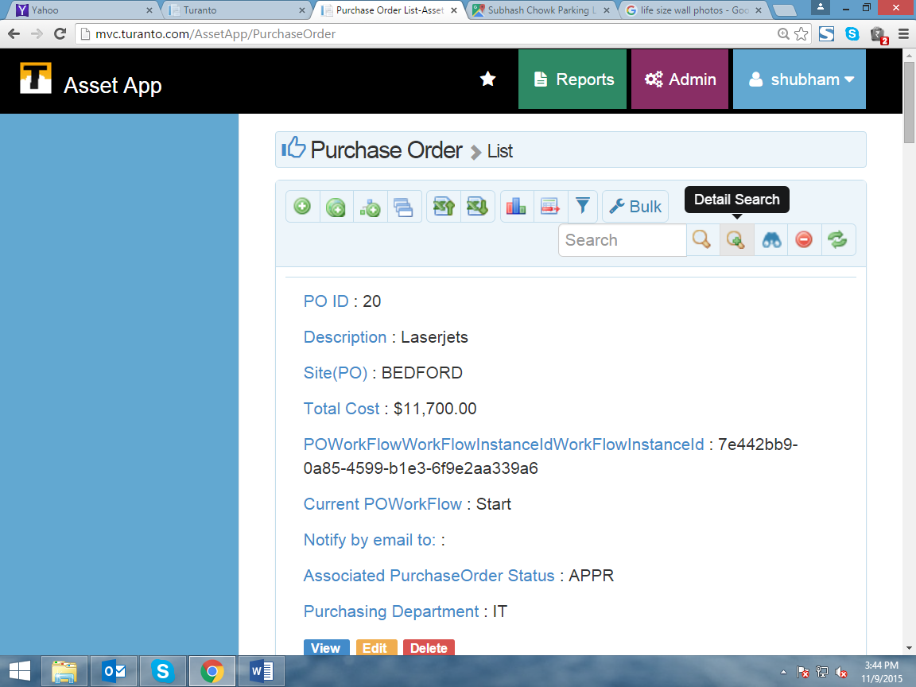 Bulk Action 31

Search Options 33

 Search Box 33

 Grid Search 33

 Detailed Search 34

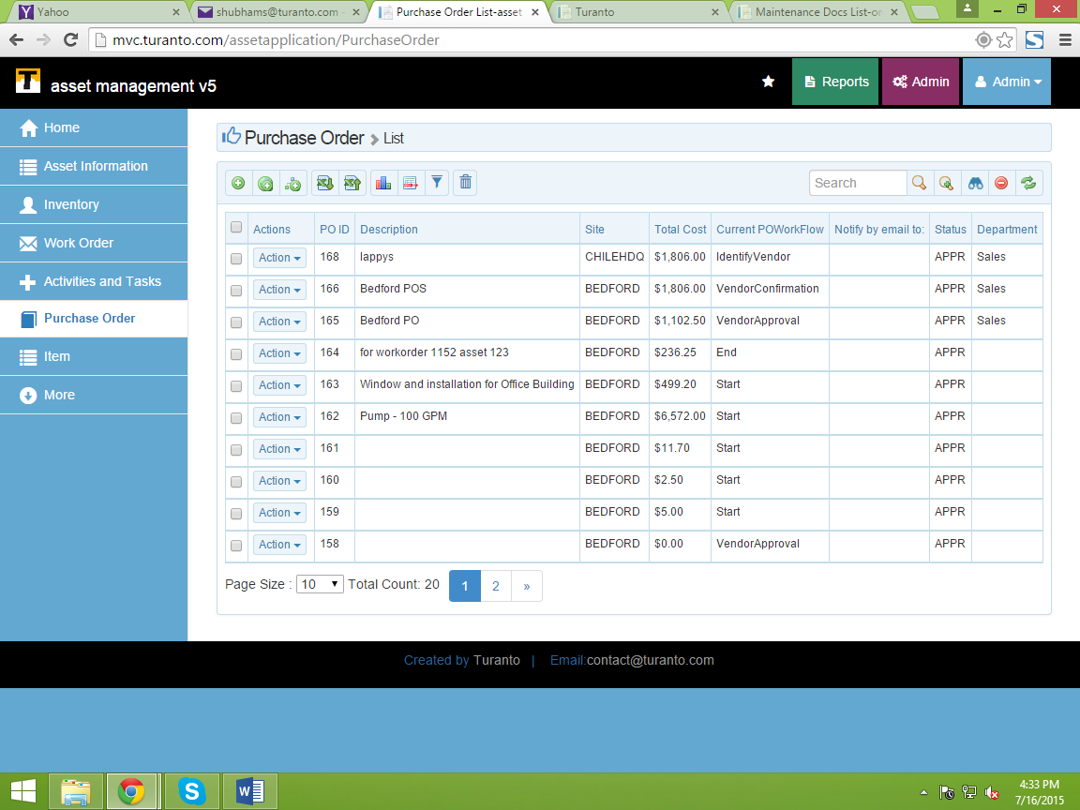 Faceted Search 34

 Clear Search 34

 Refresh Grid 34

Page Options 34

Favorites 34

Detailed Page 35

Tabs 36

Many To many Association 36

Options 37

Back 37

Edit 38

Workflow 38

Accordion 38

Copy to Entity_name 38

Chat 41

Appendix 1 42

Live Data Monitoring 42

Journal 43

Application Feedback 44

# Preface

## Intended Audience

The document is intended for individuals/organizations who use **App_Name** application developed for company: **Company_Name**. The document provides complete description of application interface and in-detail explanation of features and controls.

## Document Accessibility

The company focuses on making products, services and supporting documents accessible with great usability to its users. To that end, this document includes features that make information available to users of technology. This document is published in WORD format and does not contain markup. Accessibility standards will continue to upgrade on timely basis and Company_Name is constantly engaging itself in activities to address technical obstacles to furnish the document to all its customers.

**Accessibility of Links to External Web Sites in Documentation**

The document may contain links to other websites (not owned by Company_Name) if required. Company does not evaluate nor makes any representations regarding the accessibility of these web sites.

## Related Documents

The document is first revision in its section and available only at respective application(s) portals. The company is not responsible for about authenticity of this document, if accessed from any third party website. The documents available are:

* App_Name User Guide
* Current Security Settings
* Current Business Rules
* Security Configuration Manual
* Business Rules Configuration Manual
* General Deployment Guide
* Database Design Document
* Troubleshooting Guide

## Conventions

Following are the conventions used in this document:

Words in single inverted commas (‘) are the nouns. These words in common English sometimes are used in different manners as required. Inverted commas differentiate these words used as simple English terms and specific terms (nouns). Ex: properties, associations, datatype etc.

™: The words with TM (Trademark) as superscript are registered words and cannot be used without prior permission of respective organization for commercial and profit activities.

Hyperlinks: Hyperlinks are the content that reflects the source at another place having a web address. The hyperlinks are URLs to these web addresses and are accessible by pressing (CTRL + click) in static documents and simple clicks on web pages.

Illustrative numbers: The numbering is done in figures (for example: figure 2) for users convenience to find the data easily. The contents are arranged numerically as per the figure.

Save: For any changes you, ‘Save’ button store these changes. The save button is present in all the forms and fields in App_Name and is not repeatedly acknowledged.

Cancel: For any changes you, ‘Cancel’ button discards these changes. The cancel button is present in all the forms and fields in App_Name and is not repeatedly acknowledged.

Checkbox: Checkbox presents the conditions that could be marked as true or false. The right sign in checkbox ✓ marks the condition as true. If left blank, the system considers it as false.

Fields: Fields are the space provided to fill the data. Some fields may have conditions depending on respective section or the rules.

Back to list: This option discards the changes and redirects you to the previous page.

Save and continue: This option saves your current changes and redirects you to next page.

Next: This option without saving current changes redirects you to next page.

Previous: This option without saving current changes redirects you to previous page.

# About This Guide

The User Manual contains all essential information for the user to make full use of the information system. This manual includes a description of the system functions and capabilities, contingencies and alternate modes of operation, and step-by-step procedures for system access and use. The manual format may be altered if another format is more suitable for the particular project.

## Purpose and Scope

The purpose of this document is to specify functional structure and features of application generated for **Company_Name**. The content of document is restricted to interface of **App_Name** application.

The scope of this document is the understanding of screens and functions to use this application for end users who will perform various actions. The admin section and specific configuration settings that are specified by privileged users (application administrator(s)) are NOT covered in this document and available in separate documents.

## Point of Contact

For any queries or to make any request, feel free to contact us at Company_Email.

## Glossary

Table : Glossary

|  |  |
| --- | --- |
| **Android APK** | The downloadable android application |
| **App** | Application |
| **ASP.NET** | Open Source server-side Web Application framework |
| **Association** | Relation between two entities |
| **Browser** | The interface used to access the internet |
| **Cancel** | Discard your unsaved changes and redirects you to previous page |
| **CRUD** | Create Read Update Delete |
| **Dependent Dropdown** | Dependency of one association on another |
| **Entity** | An independent existing thing |
| **Faceted Search** | Searching information from properties of an entity |
| **Group** | Collective display of properties (and associations) |
| **Launch** | Generate the application from present model |
| **Mobile View** | The application designed according to mobile interface |
| **Model Generator** | Defines entities, properties, associations and other features of application |
| **MVC** | Model View Controller (Microsoft’s technology) |
| **Next** | Redirects you to next page in form |
| **Password** | Password is the secret key, required to access the application |
| **Permissions** | Accessibility to add/edit/delete/view data of entity |
| **Previous** | Redirects you to previous page in form |
| **Property** | The things that belong to entity |
| **Record** | Complete details of data for an entity |
| **Roles** | Set of permissions to add/edit/view/delete for each entity |
| **Save** | Save your changes you made |
| **Save & Continue** | Save your changes and keeps you on same page |
| **Username** | It is the unique field that identifies an associated user |
| **Users** | People who have access to application |
| **Value** | Specific field of a record |
| **Workflow** | Defines status of application for any particular record in entity |

# System Capabilities and Purpose

1. An application with upgradable modeling without data loss.
2. To store all the information of given object.
3. Associating different objects with each other.
4. Create users and assign them with roles.
5. Restrict user access for specific information.
6. Create reports of all the information in interactive manner.
7. Accessing applications from mobile browsers and android (APK).

# General User Interface Screen Description

## Login

The Generated Application can be accessed only by valid login id and password.

TODO: The screenshots of sample application “Asset App” is used here. Please add your application’s screenshots.

Application credentials:

URL: App_URL

Username: Users can use their username or register themselves as new user

Password: Password given to user.

Note: Your user may/may not have complete application rights. For complete demonstration contact the concerned person.

### Remember me

You can save your password on your browser using ‘Remember me’.

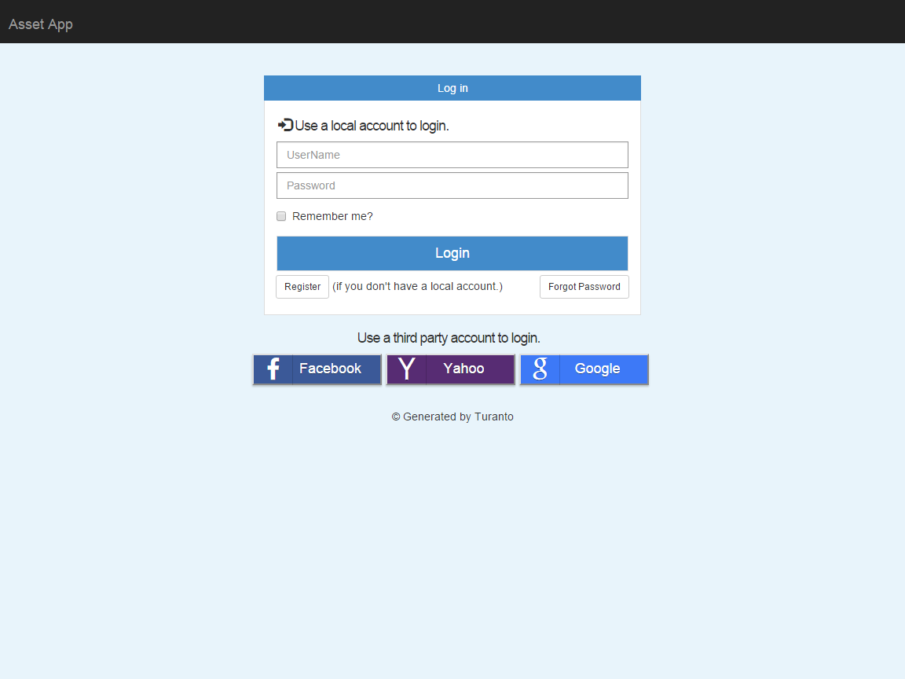

TODO: Replace this Image

Figure : Login Page of App_Name

### Register

You can access the application by registering. The registration page (Figure 2) requires a username, password, and your name and email id. The successful registration does not rights to view or access any part of application until permitted by administrator.

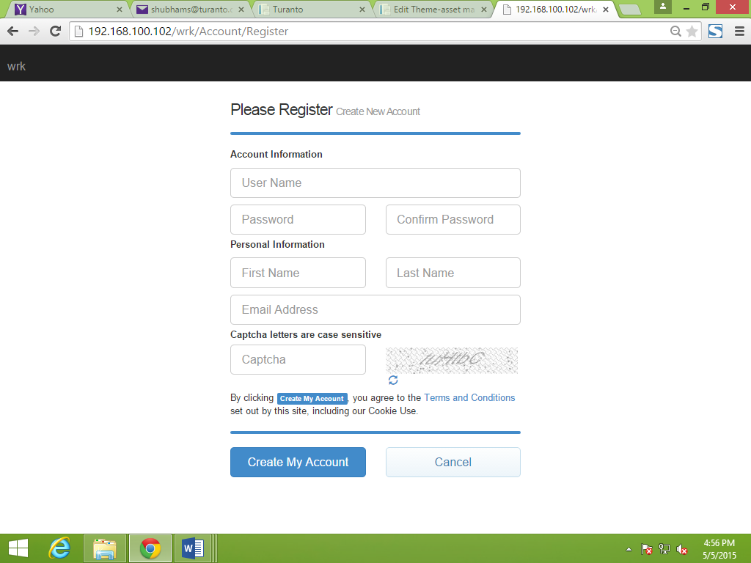

Figure : Registration page for generated application

### Forgot Password

In case you forgot your password, just provide your user name (Figure 3) and a new password will be sent to your registered email id.

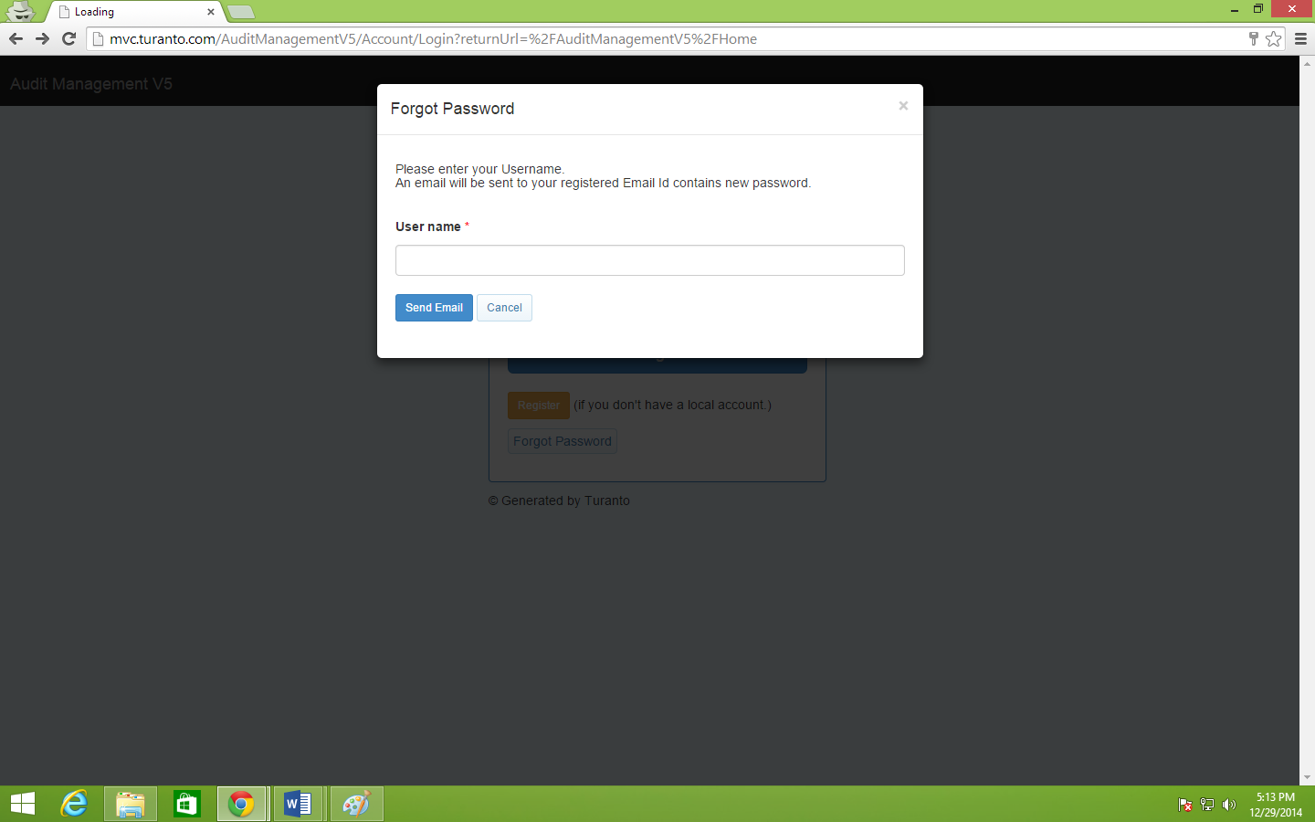

Figure : Forgot Password Popup Window

# Home Page

Home page of an application is also known as ‘Dashboard’. A dashboard of any application has mainly 6 (six) sections.

3. Dashboard Items

5. Settings List

4. Application Name

1. Main Tab List

2. All Entities

6. Favorites

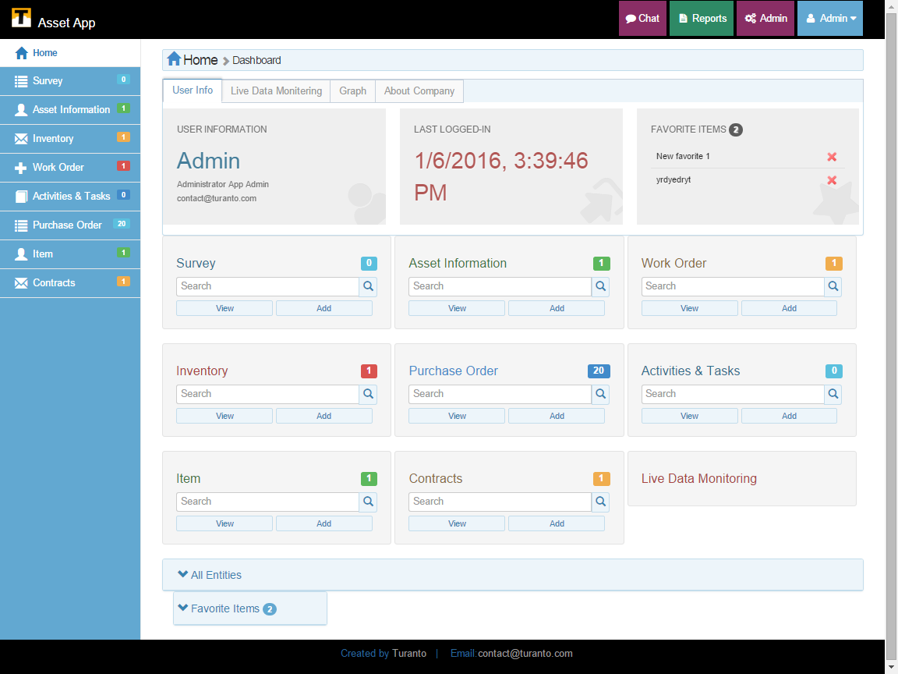

TODO: Replace this Image

Figure : Home Page of Generated Application

## Main Tab List

This section (and entities visible on your screen) contains list of entities set as the ‘Display as Tab’ are listed in main tab. The entity has three options of list, search and add to search, view and add new content respectively. If list of entities is more than the size of visible page, the left panel shows a more button and scroll bar to show list of all entities.

## All Entities

All entities set/not-set as display tab are seen in ‘More’ option.

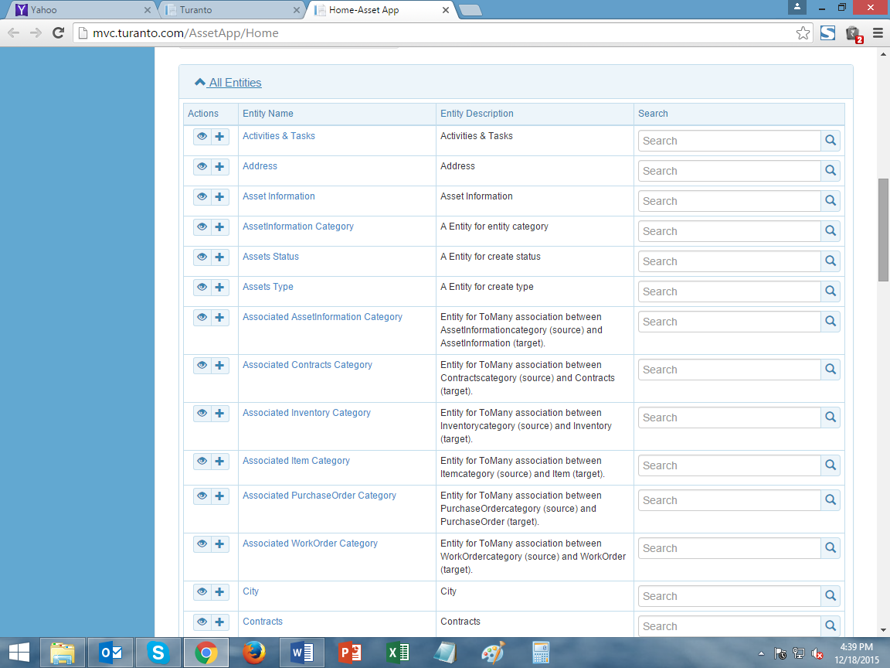

TODO: Replace this Image

Figure : Entities in ‘More’ List

## Dashboard Items

The section displays live data monitoring, graphs, uses info and about company information as tabs.

### Live Data Monitoring

Live data monitoring displays no. of records in an entity on real time basis. The graph monitors the number of records on live basis and increase and decrease of records are displayed instantly.

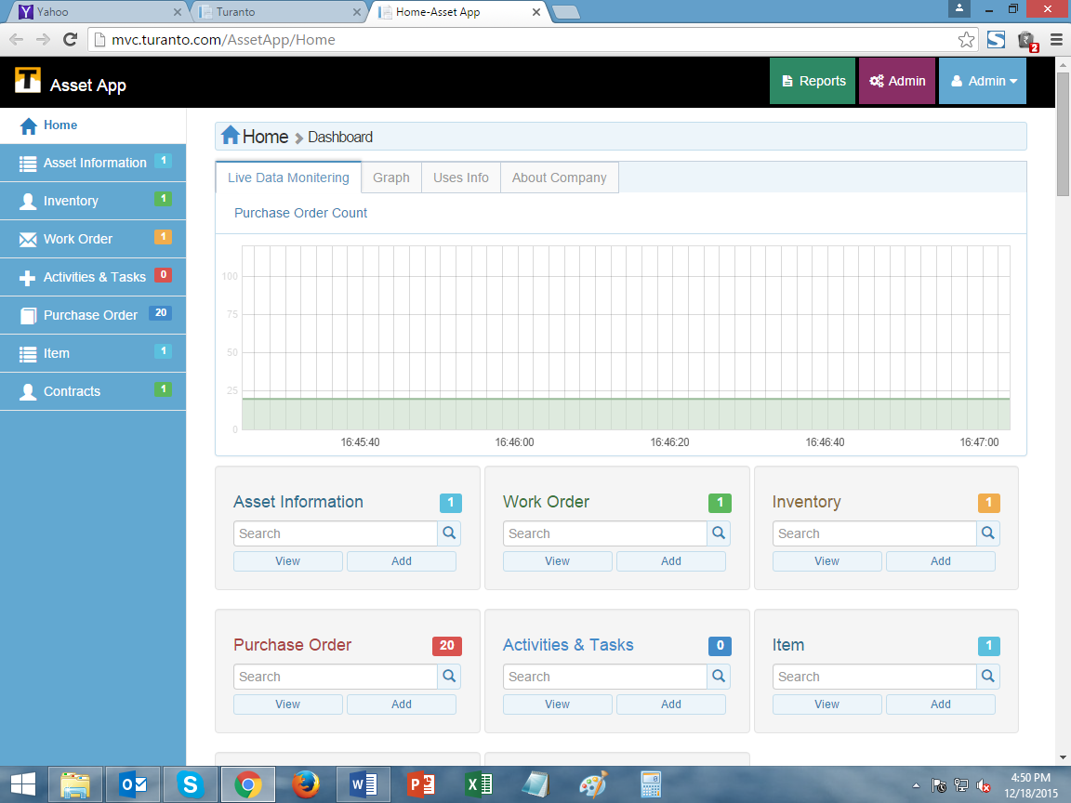

TODO: Replace this Image

Figure : Live Data Monitoring tab in dashboard

### Graphs

The section shows all the graphs available in all entities. The graphs consider one to many association to display graphs in each entity respectively.

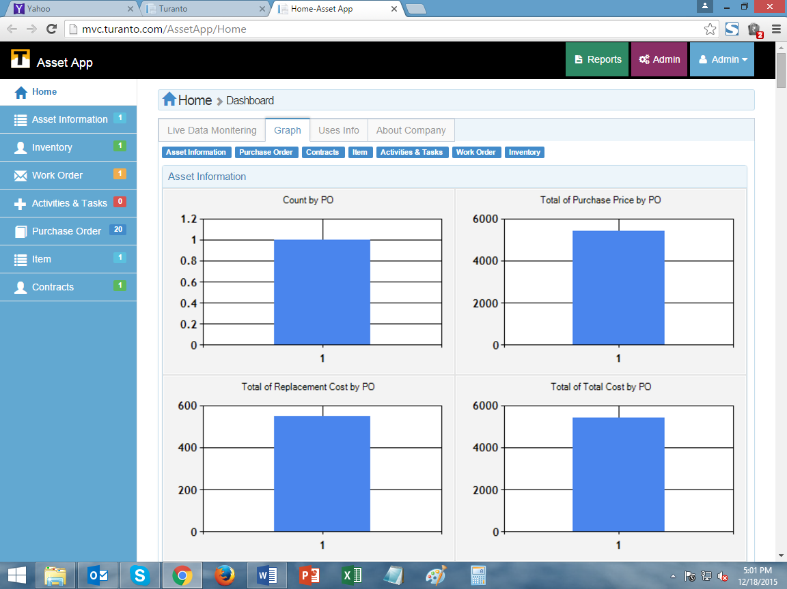

TODO: Replace this Image

Figure : Graphs tab in dashboard

### Uses Info

Uses info shows the user id and email id of logged in user. It also displays the last login time and date of user. The favorite list is also present in 3rd box.

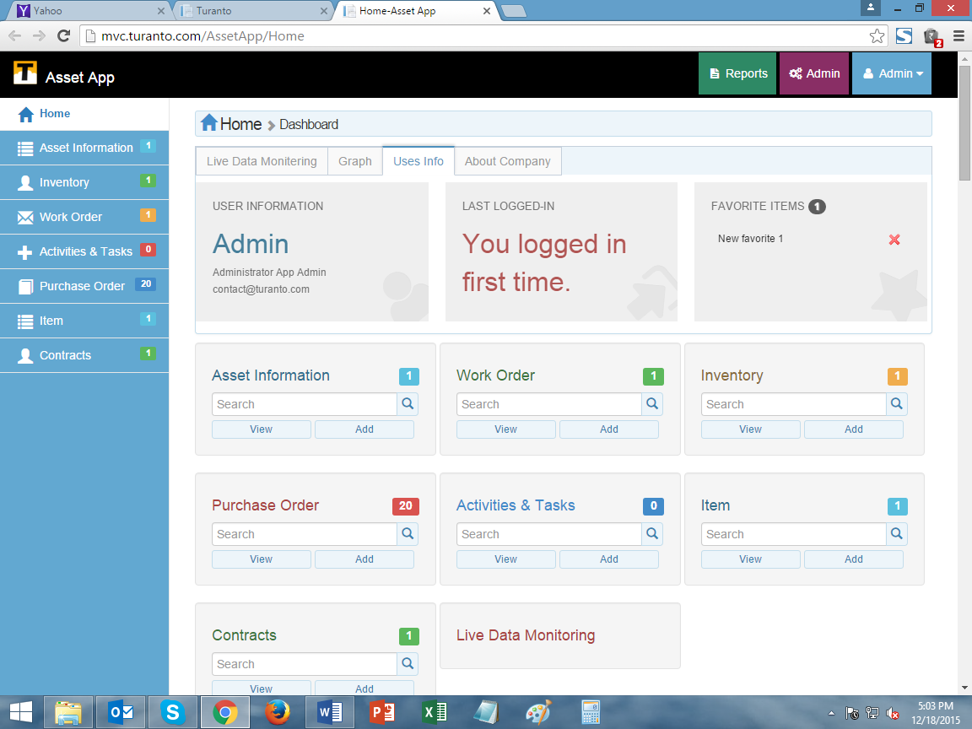

TODO: Replace this Image

Figure : Uses info in dashboard

### About Company

This section displays custom information of your company. The company information is editable through ‘set company profile’ in admin (settings) option.

## Application Name

The ‘Application Name’ is the title of your application. This application name was given in ‘App details’ page of application generator.

## Admin Settings

The options include:

### Chat

You can chat with fellow application users using chat. This option is described in details in section VII.

### Reports

This feature is currently not available in App_Name.

### Admin (Settings)

This option provides options for application settings. This option is described in details in separate document.

### Admin (profile)

This option allows you to change password (Figure 9) and log out of application.

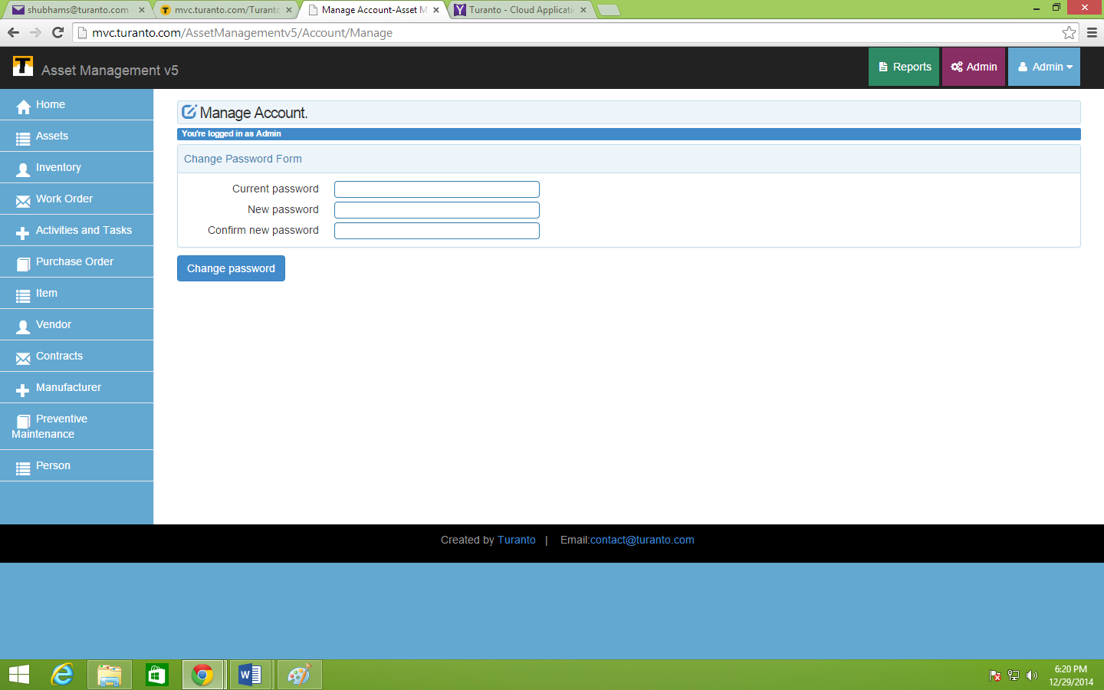

TODO: Replace this Image

Figure : Change Password

## Favorite List

The records, entities and searches can be created as favorites and link is stored on your home page. Next time you can simply access that link via your home page.

# Entity Page

The Entities of Main Tab are displayed in a Grid view. The page provides options for various things as described below:

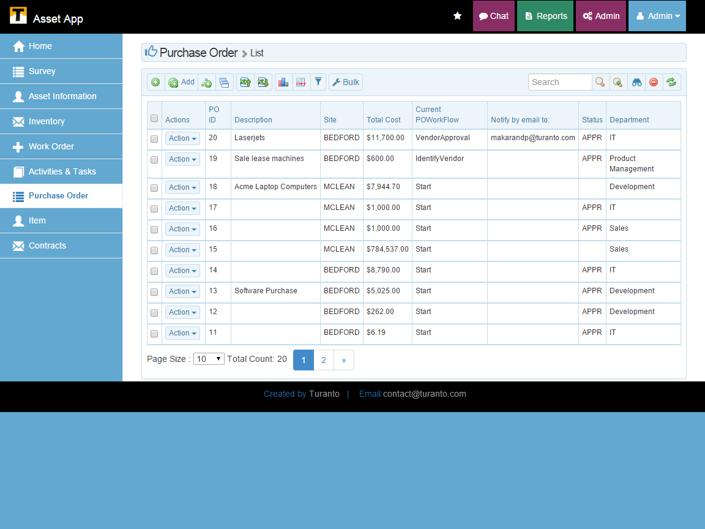

TODO: Replace this Image

Favorites

List

Search Options

Page Options

Options

List

Property List

Figure : Grid View page

## Property List

This option displays all the properties of entity with Display Condition ‘On the Grid’ in model generator.

### Select All

‘Select all’ button selects all the records on Grid Page.

### Actions

This option provides options to view/edit/wizard/delete for specific record based on role permissions assigned. For admin users all four options are available.

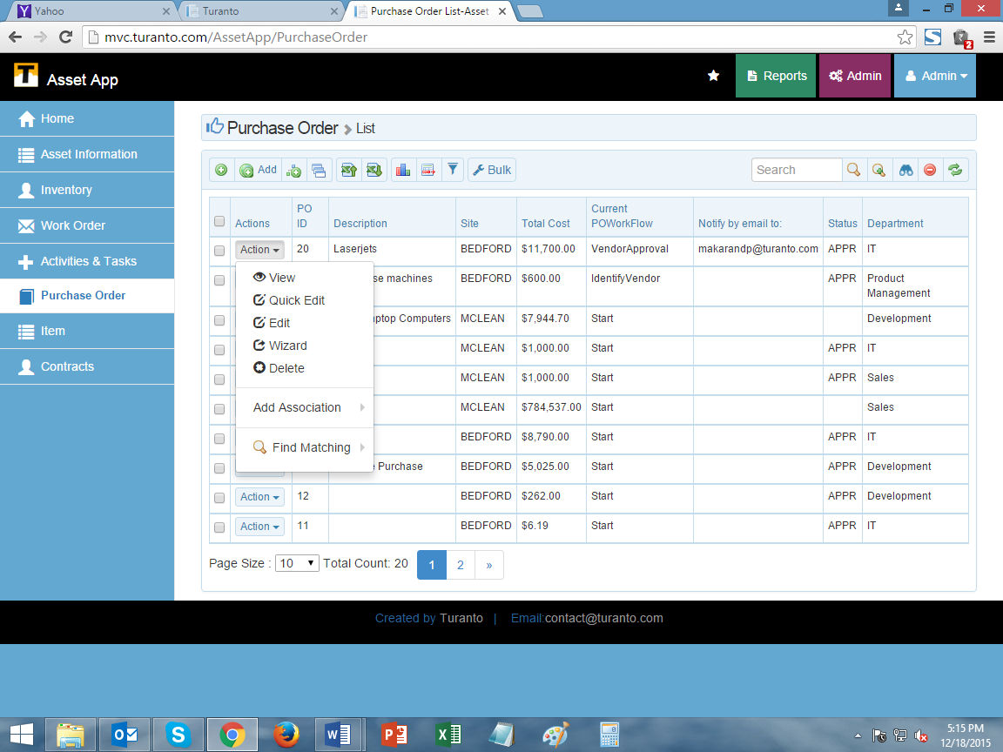

Figure : Actions Options

Entity ActiON - View: Takes you to the Details page but permissions to edit field are restricted.

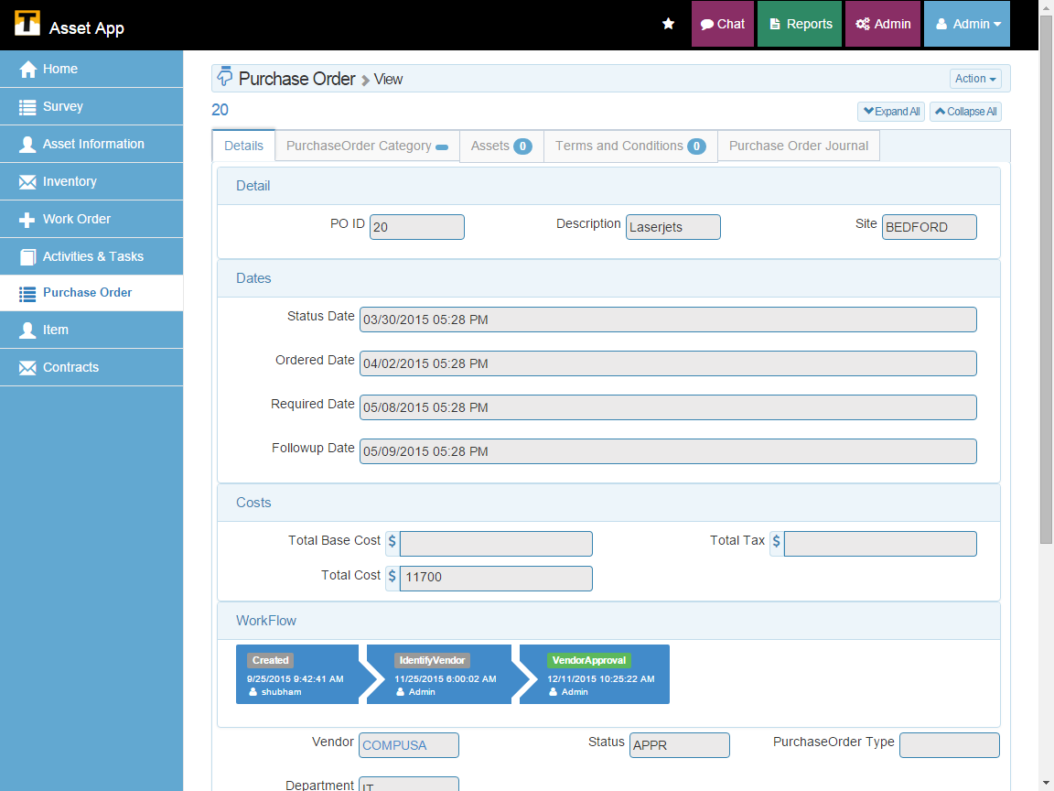

TODO: Replace this Image

Figure : View (Details) Screen of Record

Entity Action - Quick Edit: Opens the popup to edit record

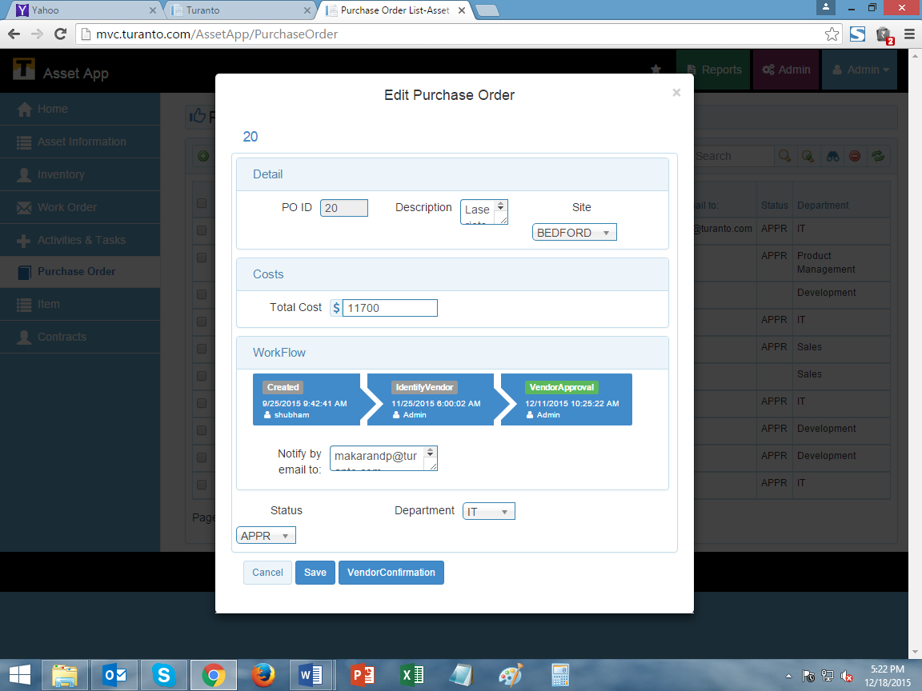

TODO: Replace this Image

Figure : Quick Edit popup of record

Entity Action - Edit: Takes you to the Details page with permissions to edit field enabled.

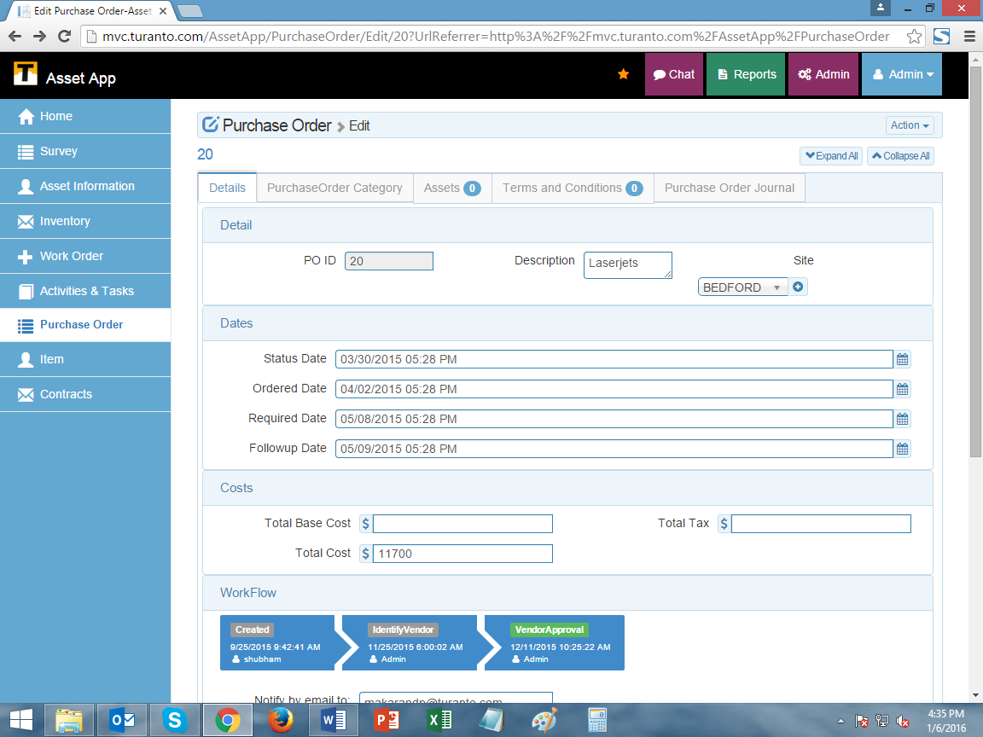

TODO: Replace this Image

Figure : Edit Screen of record

Entitiy Action - Wizard: Takes you to the wizard view with permissions to edit field.

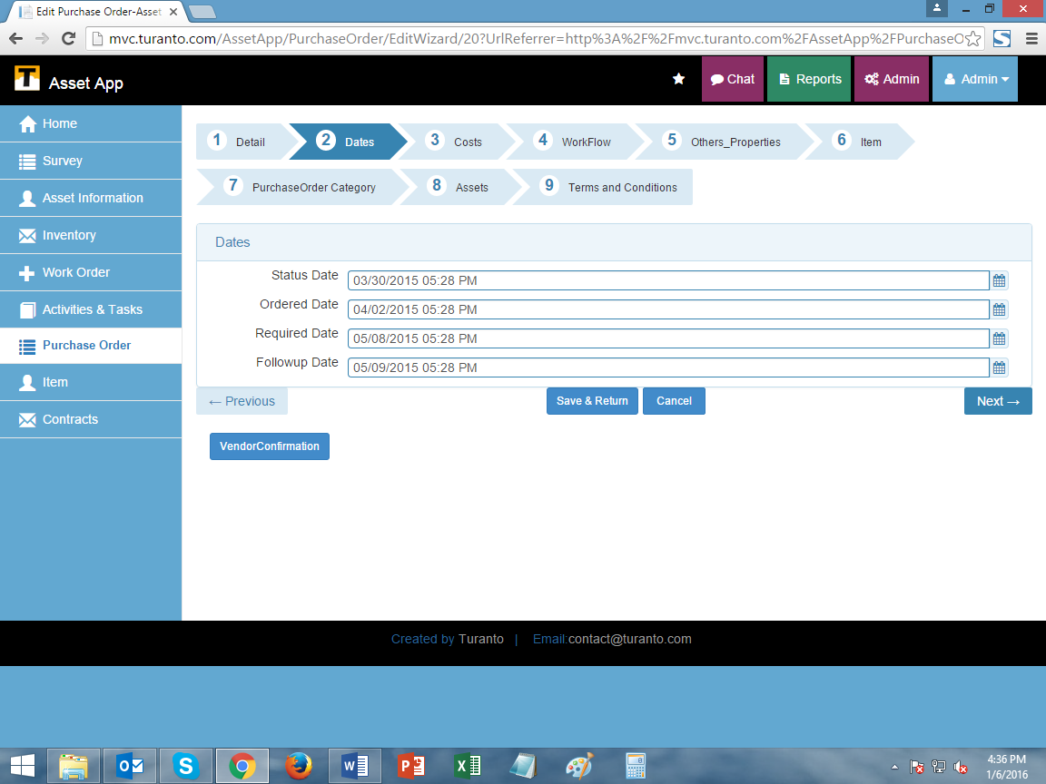

TODO: Replace this Image

Figure : Wizard screen of record

Entity Action - Delete: Delete the record.

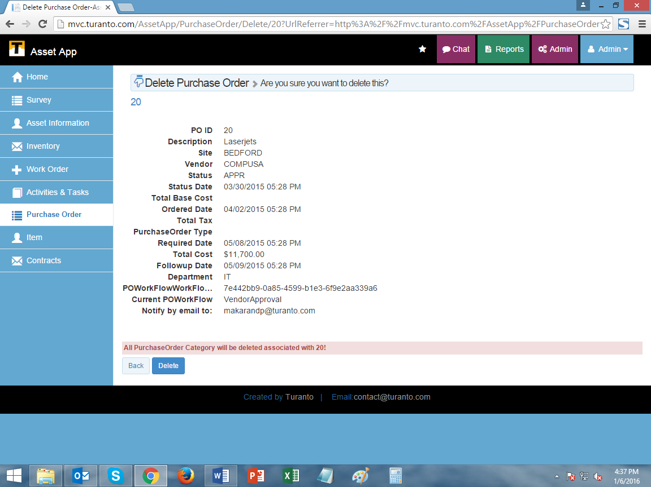

TODO: Replace this Image

Figure : Delete Page of record

Entity Action - Add Association: You can add the values in associated entities (One to Many) directly through Home Page using this button.

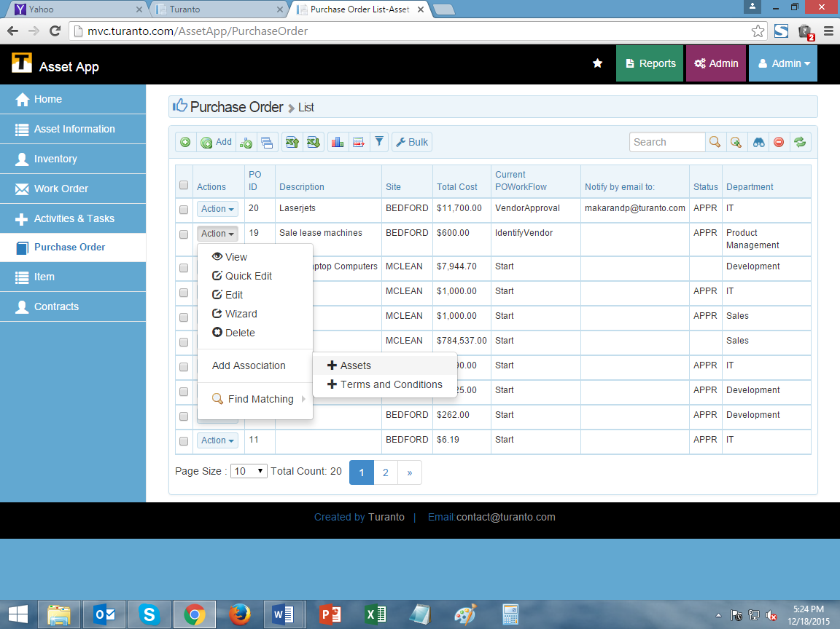

TODO: Replace this Image

Figure : Entities with one to many records for association

Find Matching: Find the records of another entity based on filter criteria.

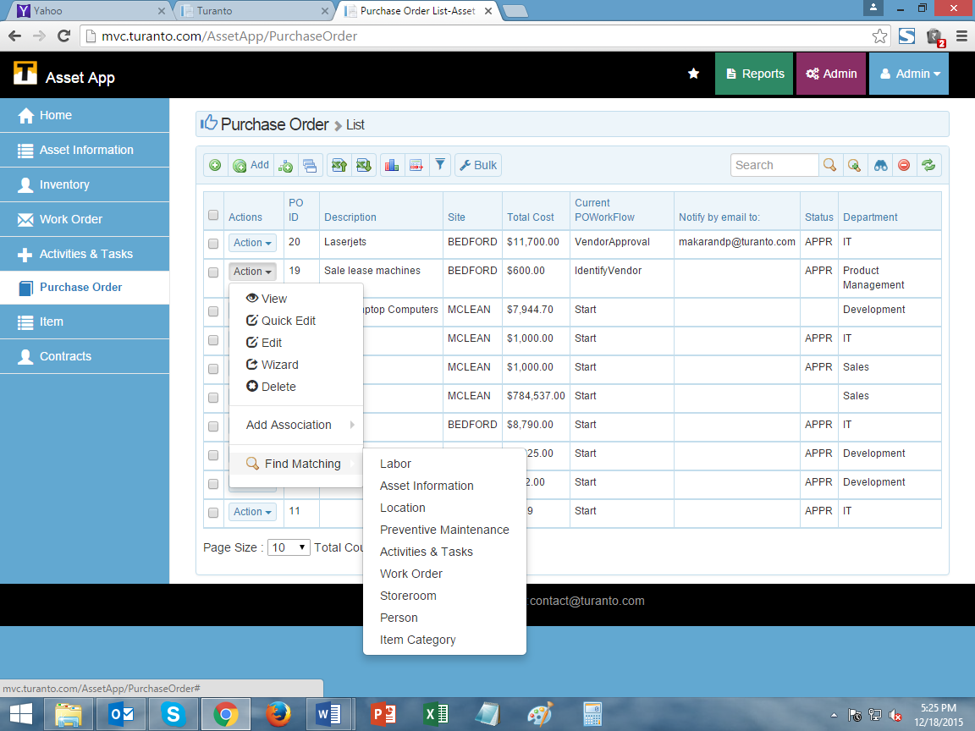

TODO: Replace this Image

Figure : Entities in find matching have a common entity of association

The filter criteria is selected internally and based on association. A search button is visible when two entities (one is source and one is target; you will see find matching button in both entities) are associated with a common entity. For example: Many persons have many skills, many jobs require many skills. Person and Jobs entities are associated with a common entity ‘skills’. So a person can directly search for relevant jobs using ‘find matching’ option.

### Workflow

The workflow property is created when you create a workflow and assign it to the property. This workflow displays the steps of status (only admin can access the workflow).

### Notify by email to

The section shows the email address of person to whom the notifications for change in workflow will be sent. If notification is enabled, it will display as on grid.

## Options list

The options in this list are related with data. The visibility of these options is controlled by ‘Set Options’ in Entity menu of model generator.

### Quick Add

This option opens a popup window to add a new record. The form have the fields of properties only displayed on grid.

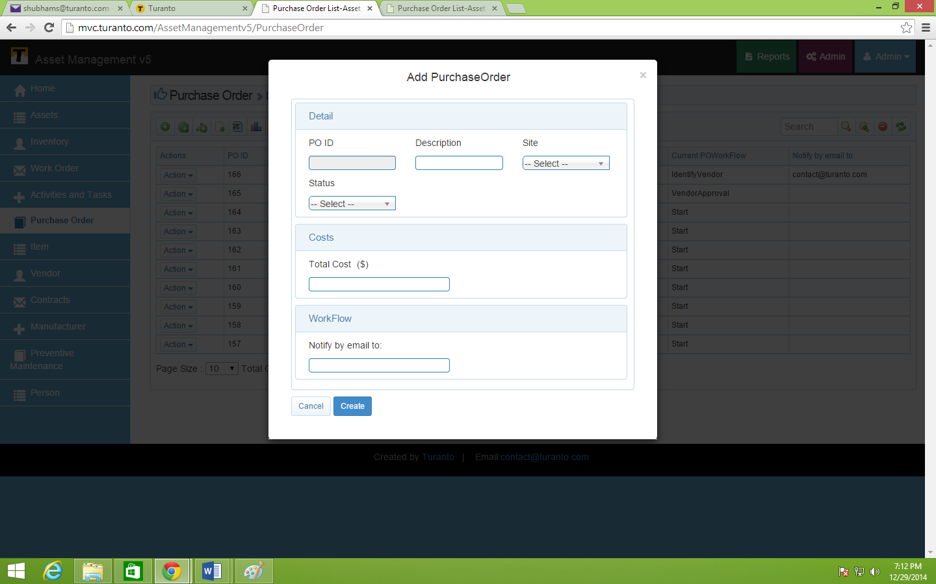

TODO: Replace this Image

Figure : Quick Add View

### Full Add

Full Add provides form to add the complete details of entity. The full add is a one page form and properties are cascaded according to their groups. ‘Create’ button redirects you to grid view of entity and ‘Create & Continue’ saves your changes but keeps you on same page.

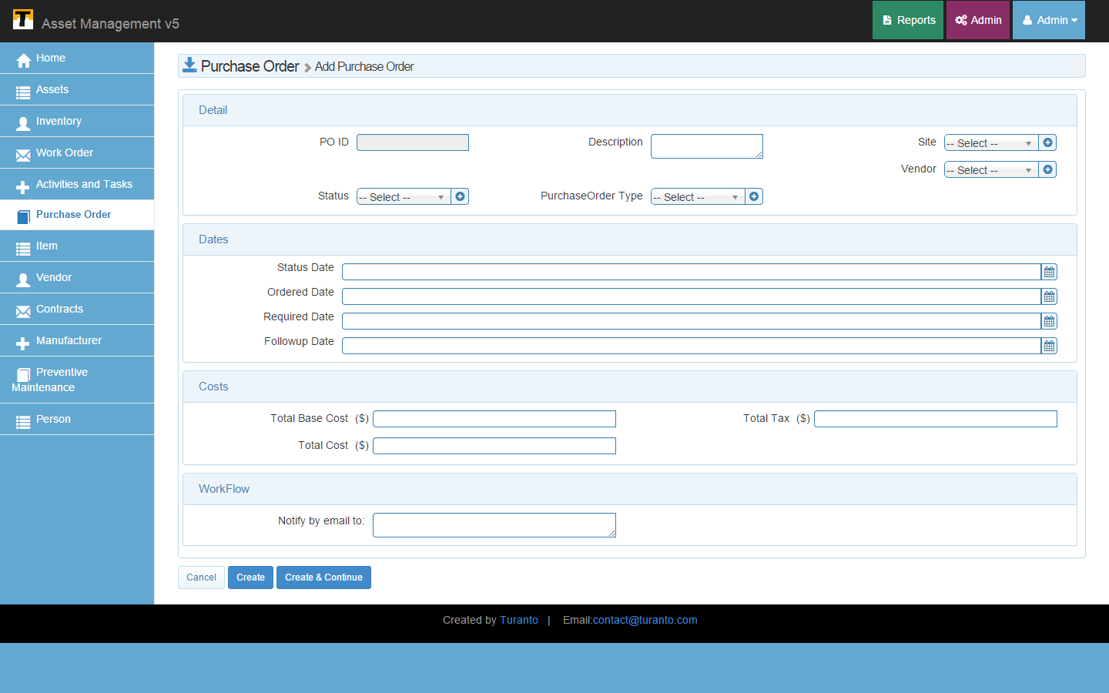

TODO: Replace this Image

Figure : Full Add Page

### Add Wizard

Add Wizard option displays one group per page to add details of entity. The groups are numbered in ascending order of display order. ‘Save & Return’ button redirects to entity’s grid view (if all mandatory fields are provided with data). ‘Next’ and ‘Previous’ buttons navigate to different groups sequentially.

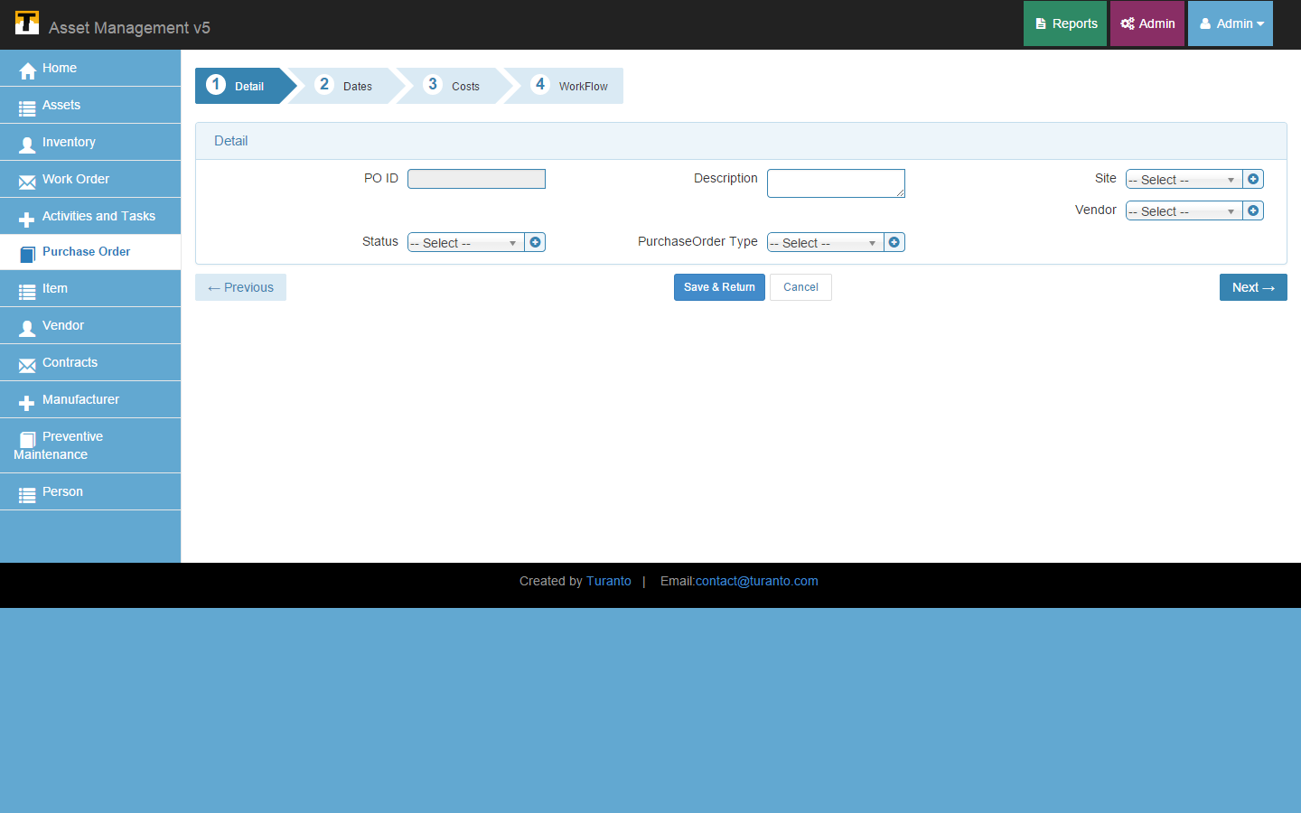

TODO: Replace this Image

Figure : Add Wizard Page

### Copy Entity

Copy entity button copies records from one entity to another entity. The button on grid page copies records from another entity to current entity.

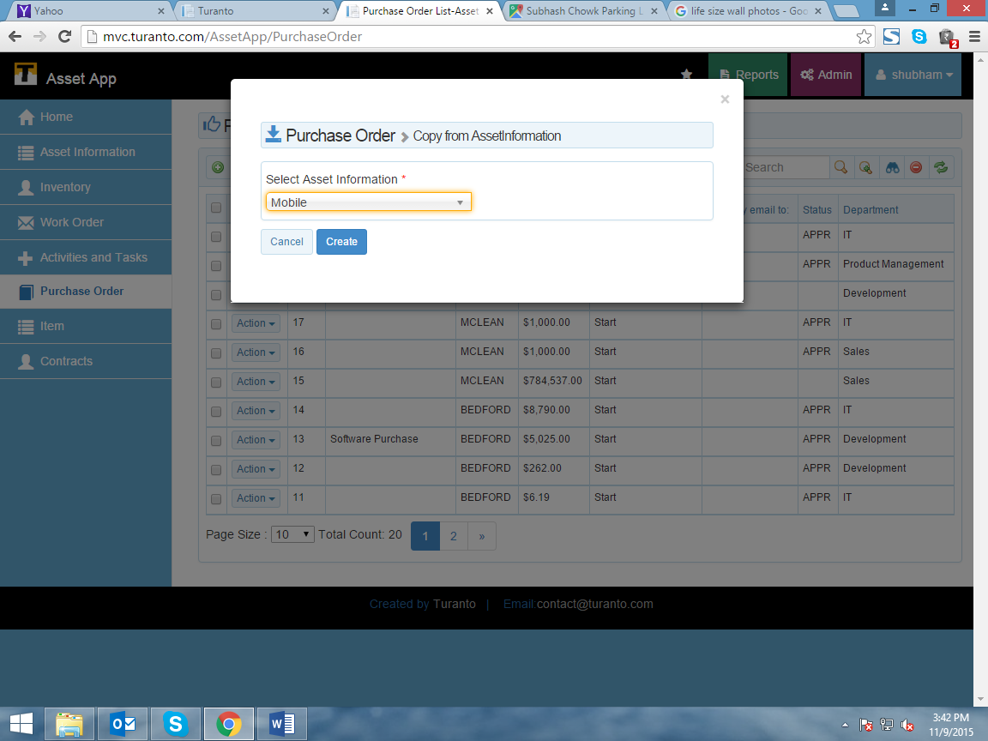

TODO: Replace this Image

Figure : Copy Entity popup

### Import Excel

The data of entity can be imported directly from Excel sheet and CSV file. In a excel sheet, the data in first row is considered as header. This header is used to map the properties. The headers that have same name as of property are automatically mapped. For remaining properties, data under selected headers will be taken as value of particular field.

The associations of entity can be mapped with existing value of associated entities by selecting the second column. If the two values are identical, the existing records will be mapped with respective records. In else case, the new records will be created.

You can save the column mapping with different names and use it to upload specific columns of files to an entity.

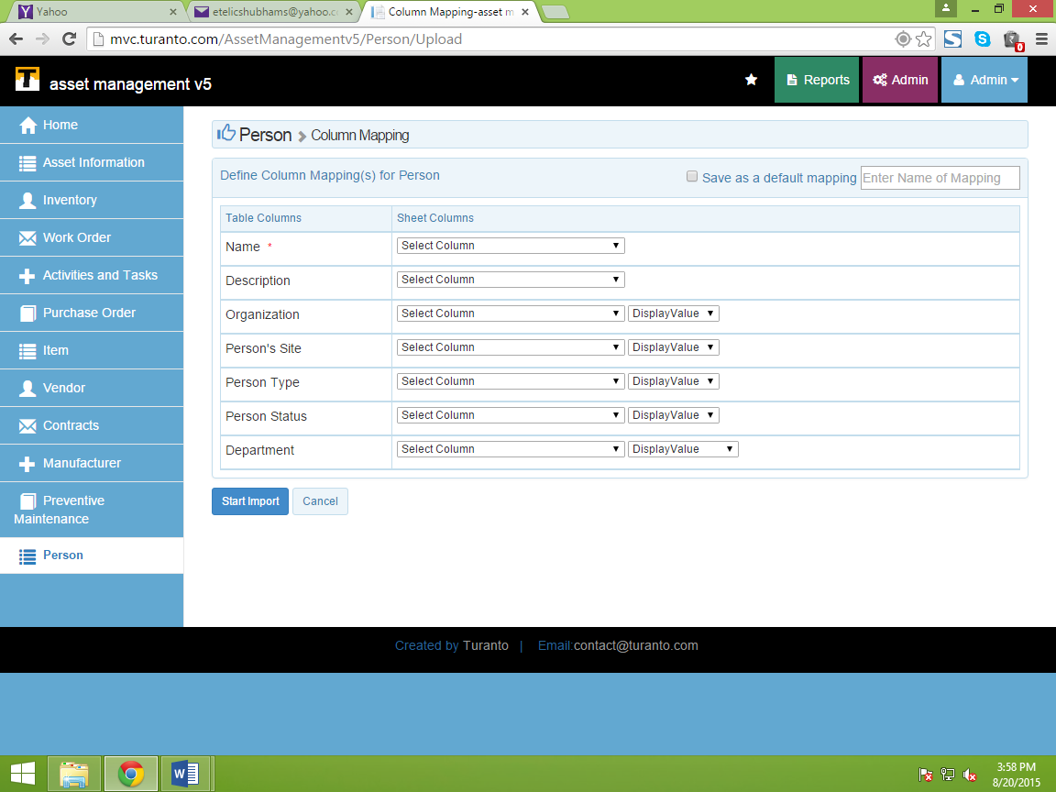

TODO: Replace this Image

Figure : Import Excel

So Next time while adding a new file to this entity, the mapping can be used from dropdown (multiple mappings can be saved by clicking ‘Save as a default mapping’) to bypass define column mapping and confirm import from data preview page.

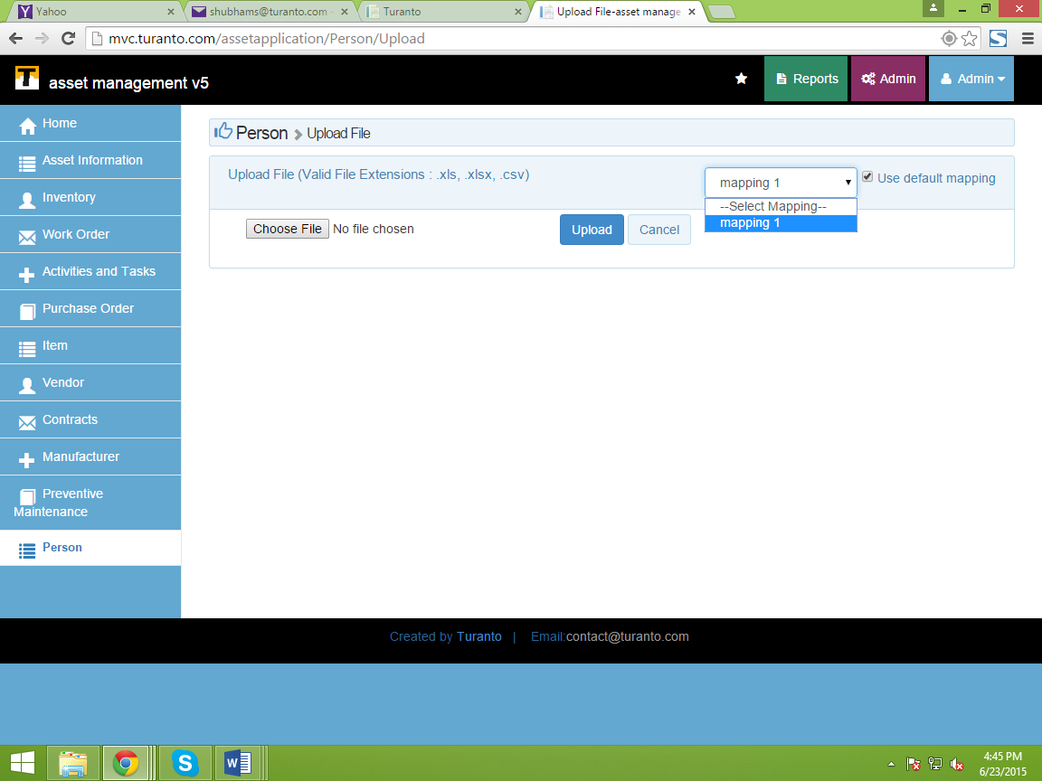

TODO: Replace this Image

Figure : Mapping Selection while Uploading File

### Export Excel

‘Export Excel’ exports the data of grid in excel format. The property name in excel file is header and values of these properties falls under respective columns.

### Show Graph

The graphical representation of data can be seen as graphs for respective entity. The graphs display four classes of data for all the one-to-one associations in the entity. If the items in associated entities are less than bar graphs are used and if items are more than pie chart is used. The four classes are:

* Count by
* Total of Total Base Cost by
* Total of Total Tax by
* Total of Total Cost by

Sample Graph:

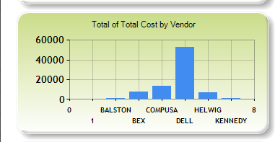

TODO: Replace this Image

Figure : Graph

### Show/Hide Column

If you don’t want to see any specific property, uncheck the property and it will be hidden from grid. In following figure (Figure 26) display property is unchecked.

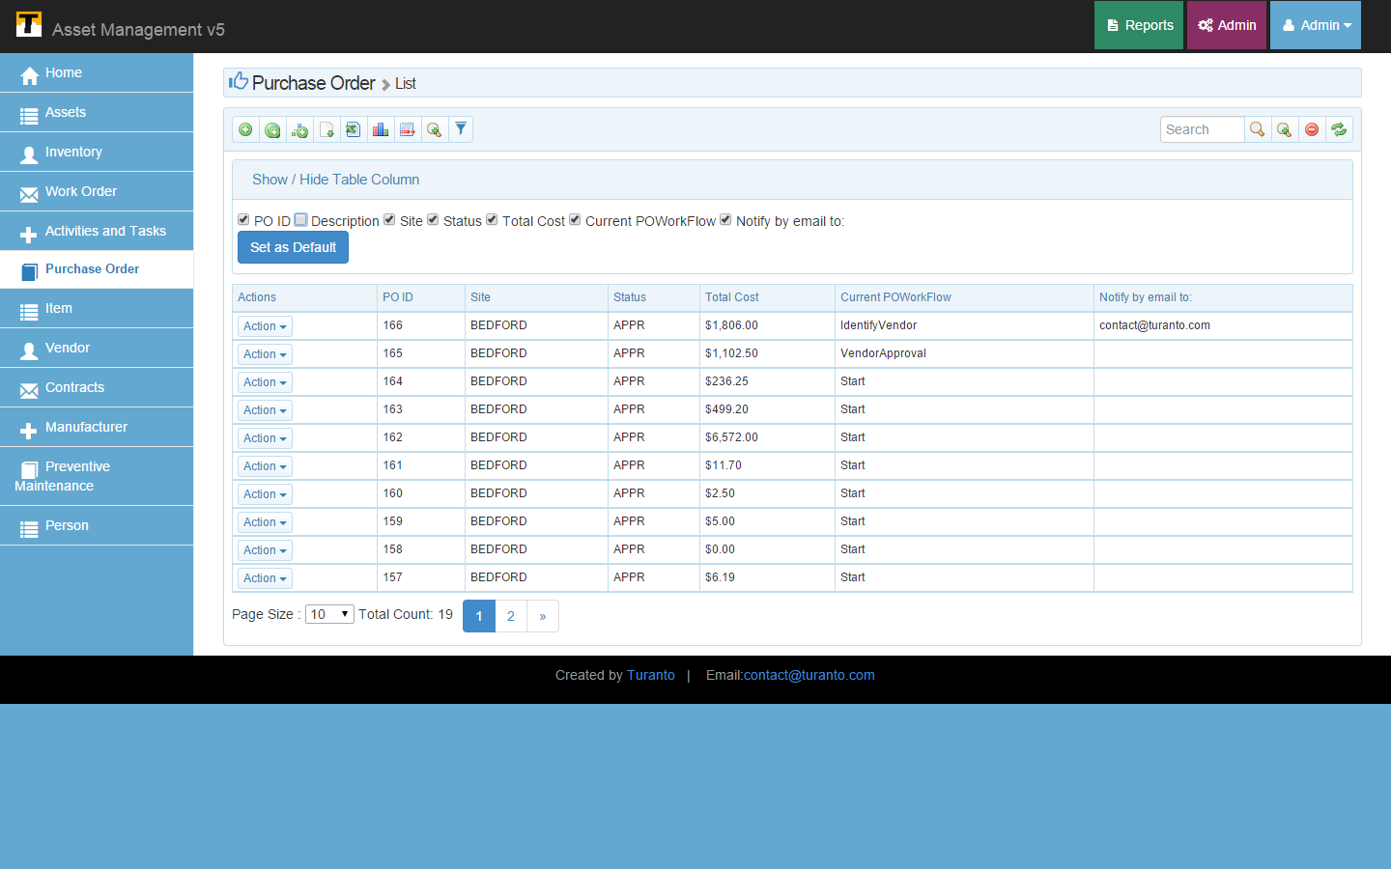

TODO: Replace this Image

Figure : Show/Hide Property

### Filter- Group by

This option filters the records based on one to one associations present in entity. On selecting an association, the values of that associated entity are displayed as tabs. On clicking on that value, records having those values are displayed.

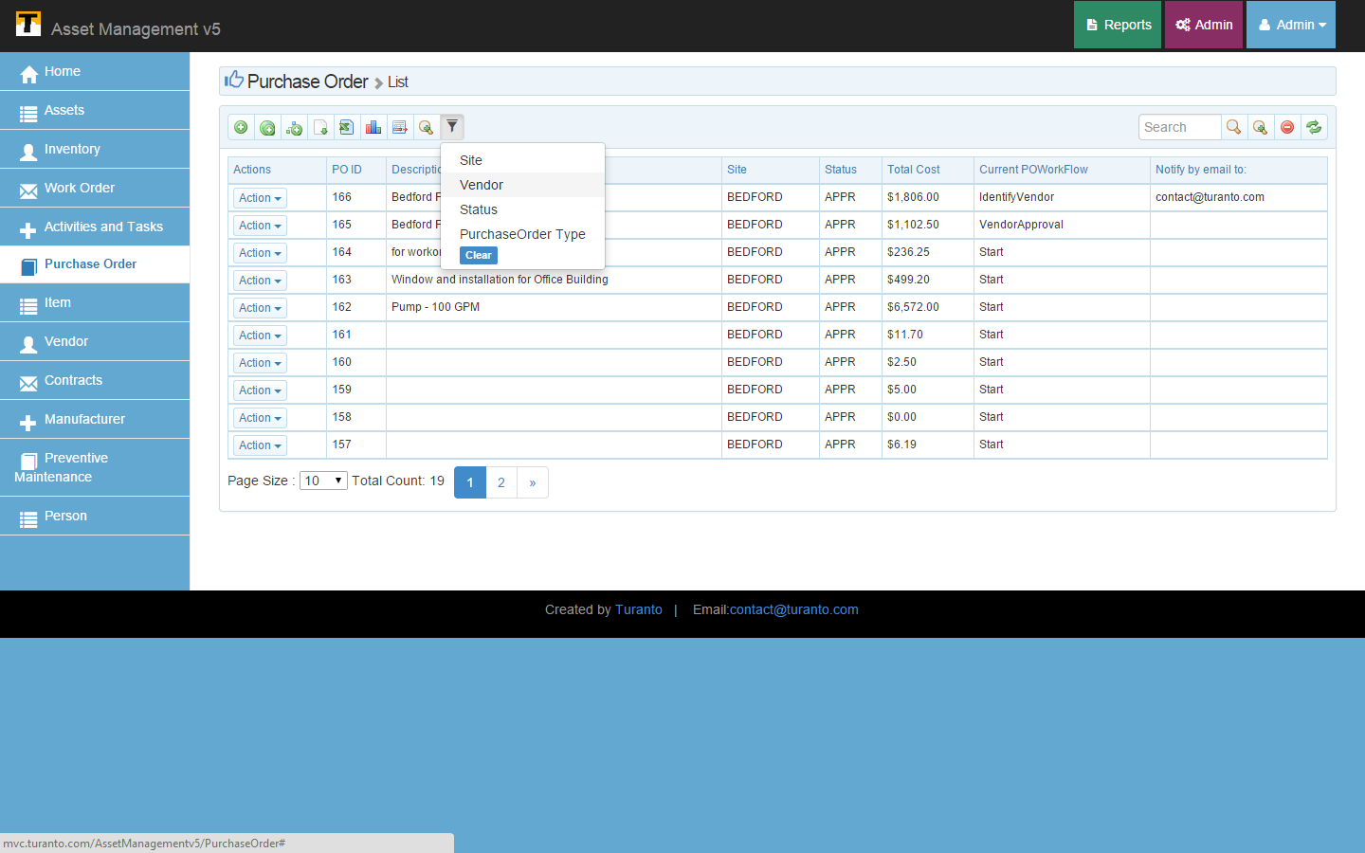

TODO: Replace this Image

Figure : Example-Filter Group by (TODO: Vendor Selected)

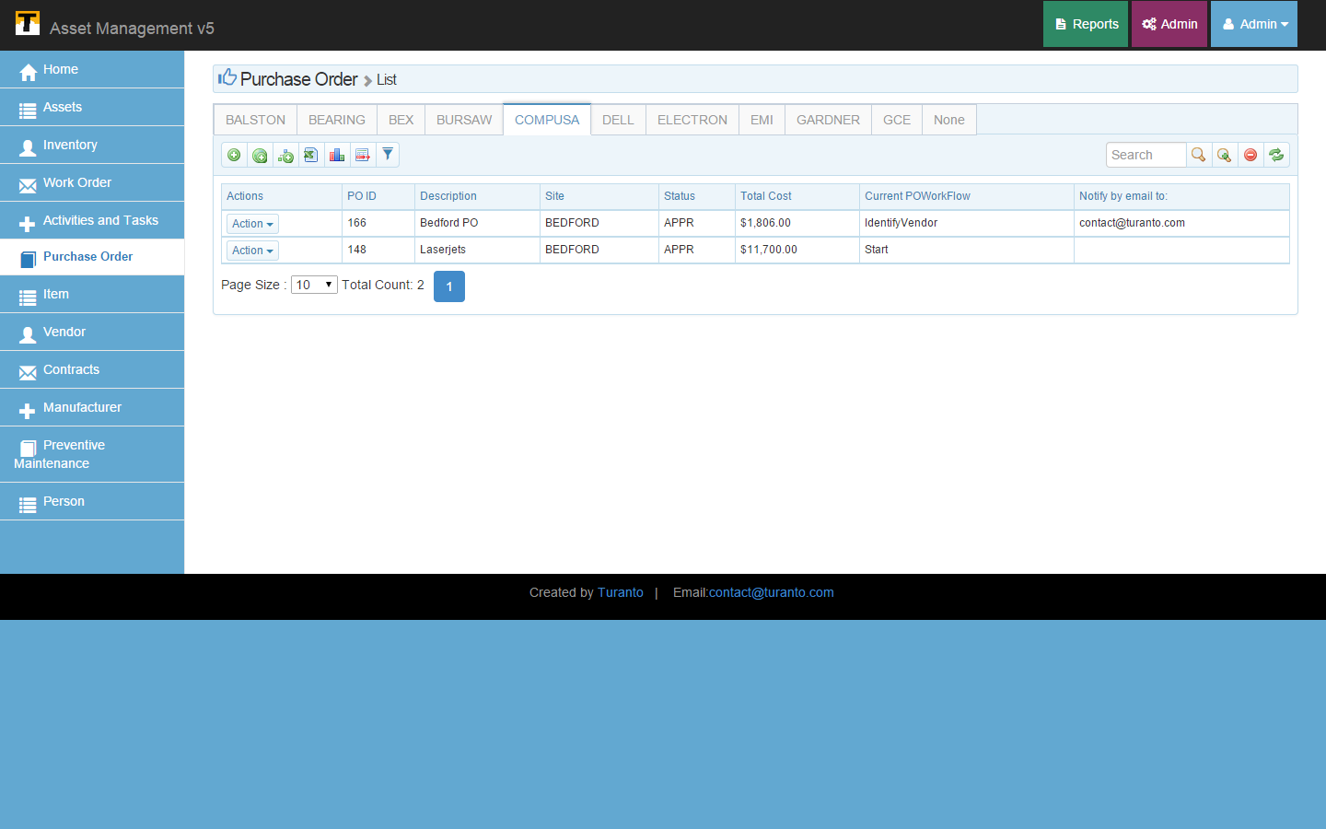

TODO: Replace this Image

Figure : Example Filter Group-by (TODO: List of Vendors arranged in Tabs)

### Bulk Action

Bulk Action Executes on the selected records. By default, ‘Delete’ and ‘Update’ is available under this option.

**Bulk Delete**: Bulk Delete deletes the selected records in one go. The option opens a popup box to confirm the delete of selected records.

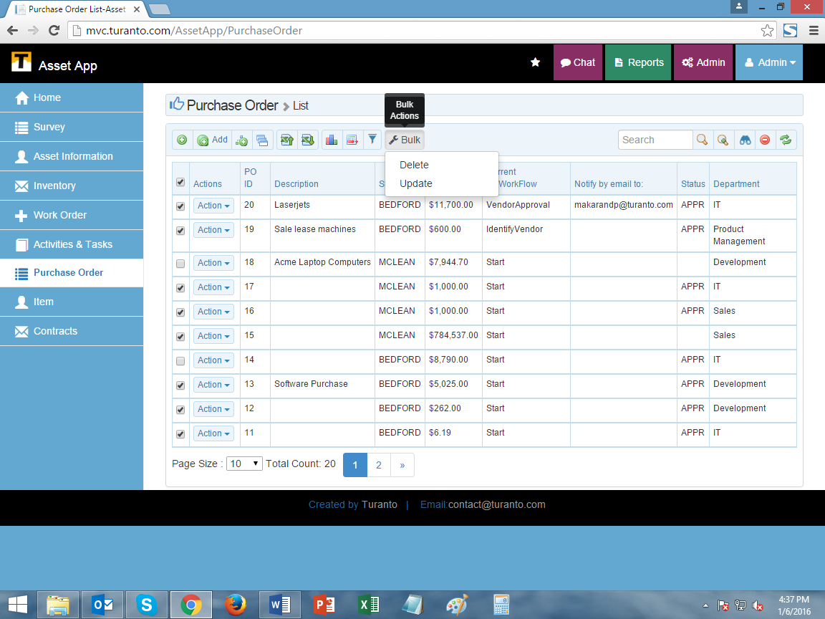

TODO: Replace this Image

Figure : Bulk Delete

**Bulk Update**: This option updates the records in specific properties/associations of more than one record. The action is irreversible and updates all the records selected in list.

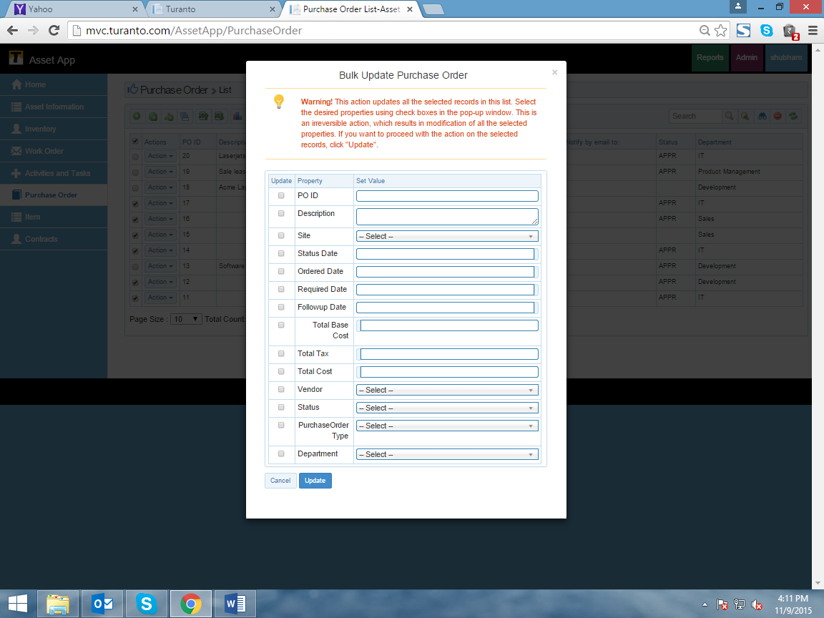

TODO: Replace this Image

Figure : Bulk Update

## Search Options

The options are related with search. App_Name has variety of search facilities in its application.

### Search Box

Enter your search details here. Application match the query in search box with records in entity and displays the matching results.

### Grid Search

Grid search match the query only to fields present in grid.

### Detailed Search

Detailed search match the query to all the fields of properties present or not present on grid page.

### Faceted Search

Faceted search provides the option to search the records with particular values of properties. For example if search is made using order date and required date, the data falling in this category will be displayed.

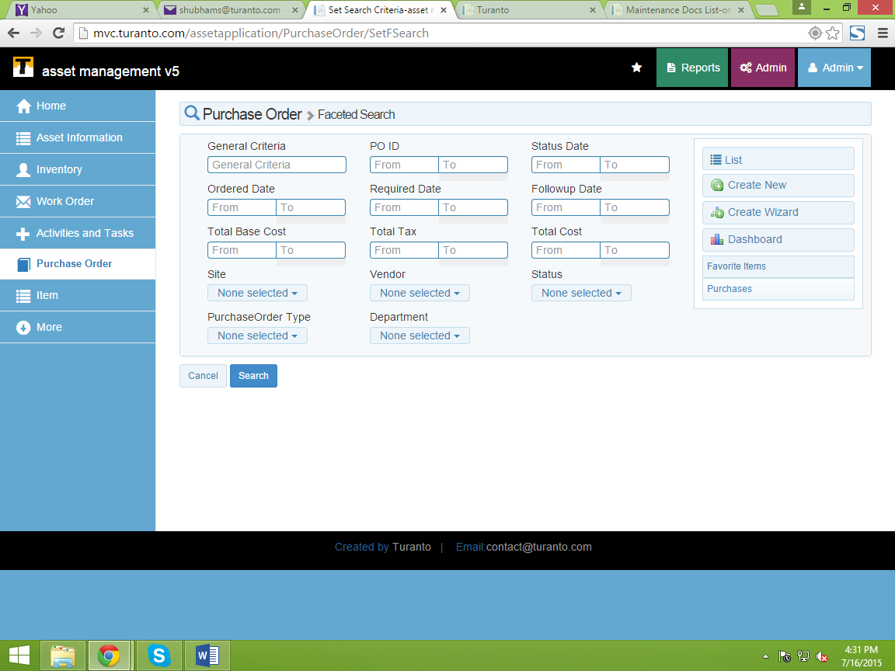

TODO: Replace this Image

Figure : Faceted Search

### Clear Search

Clear your search and brings default grid view

### Refresh Grid

Refresh the Grid menu.

## Page Options

Page options provide the customization to display page of user’s choice of size. The ‘Page Size’ displays number of records per page. You can change the page size by selecting the number of records to be displayed per page. ‘Total count’ displays number of total records present in entity. If the number of total records is larger than number of records on ‘Page size’, the remaining records can be navigated using page numbers (just like we see a book).

## Favorites

You can now save your favorite record and see them directly through the home page of application. The favorite button is present for search, faceted search, association, entity, detailed page of entity and any type of record in application.

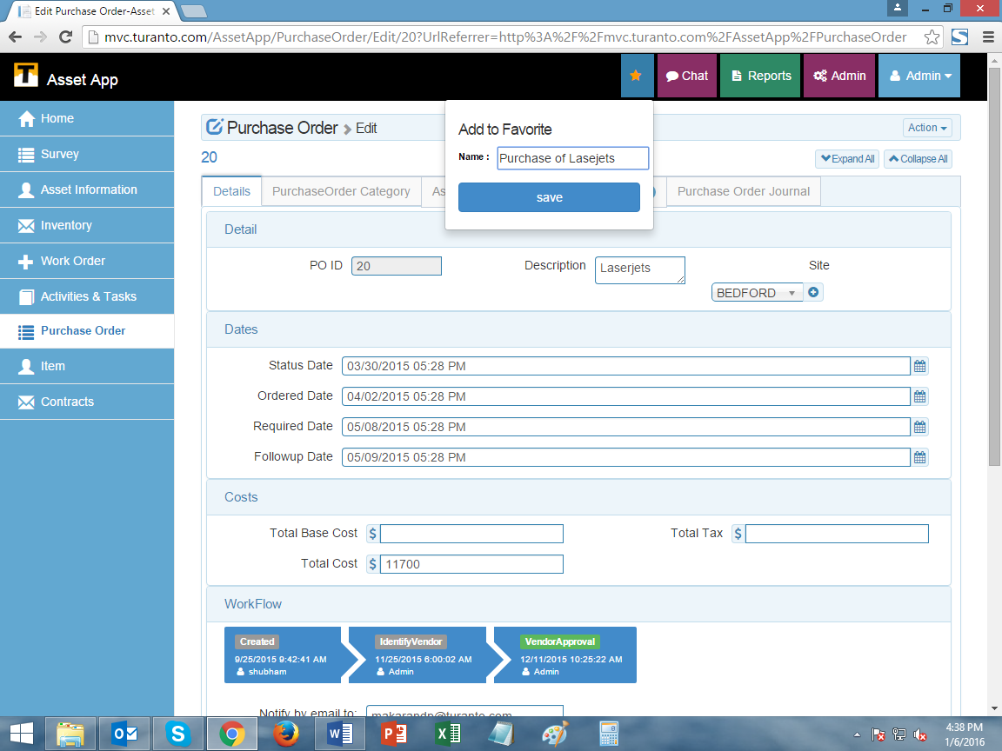

TODO: Replace this Image

Figure : Adding Favorite

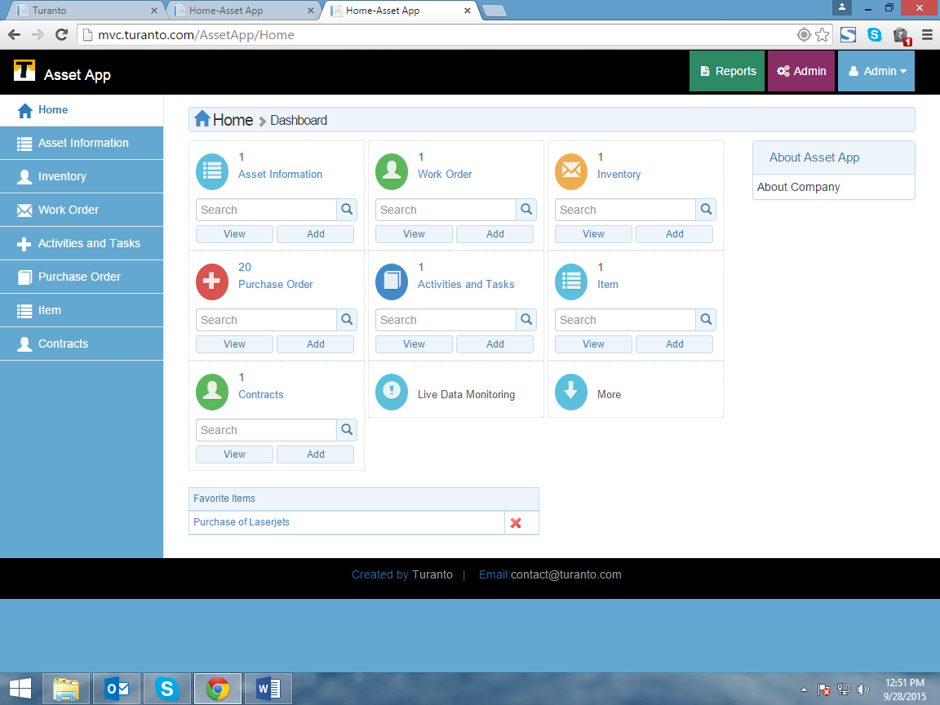

TODO: Replace this Image

Figure : Favorite list on Home Page

# Detailed Page

The detailed page is displayed when a record is double clicked. The detailed page shows all the properties of an entity (mandatory & optional), filled or unfilled.

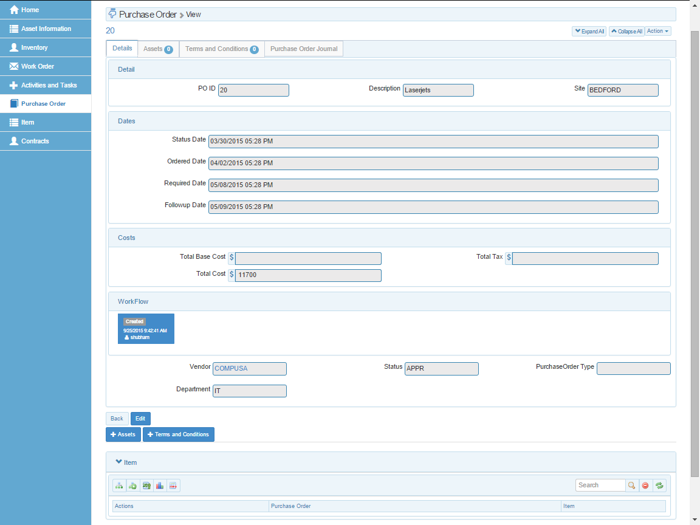

TODO: Replace this Image

Accordion

Workflow Status

Options

Tabs

Figure : Detailed View of Records

## Tabs

The tabs show the entities which have 1: M and M: M association. In the tab of 1: M association, you will see the option to create a new record while in tab of M: M association, you will see a selection box to map the records.

### Many To many Association

In ‘Many’ to ‘Many’ Association, the records of entity 2 can be added and removed to entity 1 through selection box using Quick Add and Full Add buttons (Figure 35). The selection box picks the list of all the records of entity 2 in left section. You can select the records you want to associate with entity 1 and save. In case if you want to remove multiple records from association at any instance of time, you can use quick add feature to do so.

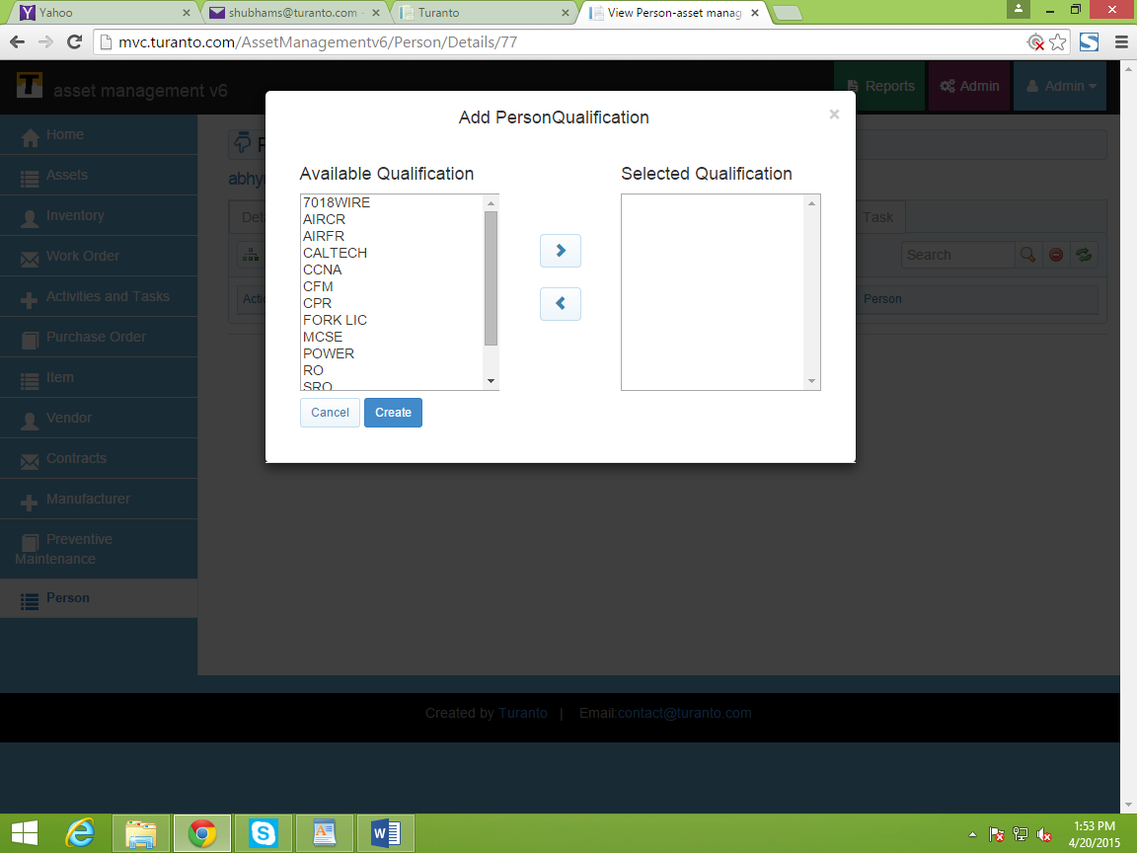

TODO: Replace this Image

Figure : Adding Values in Many to Many Association

## Options

The detailed page has two options - ‘Back’ and ‘Edit’.

### Back

This option redirects you to the grid view of records.

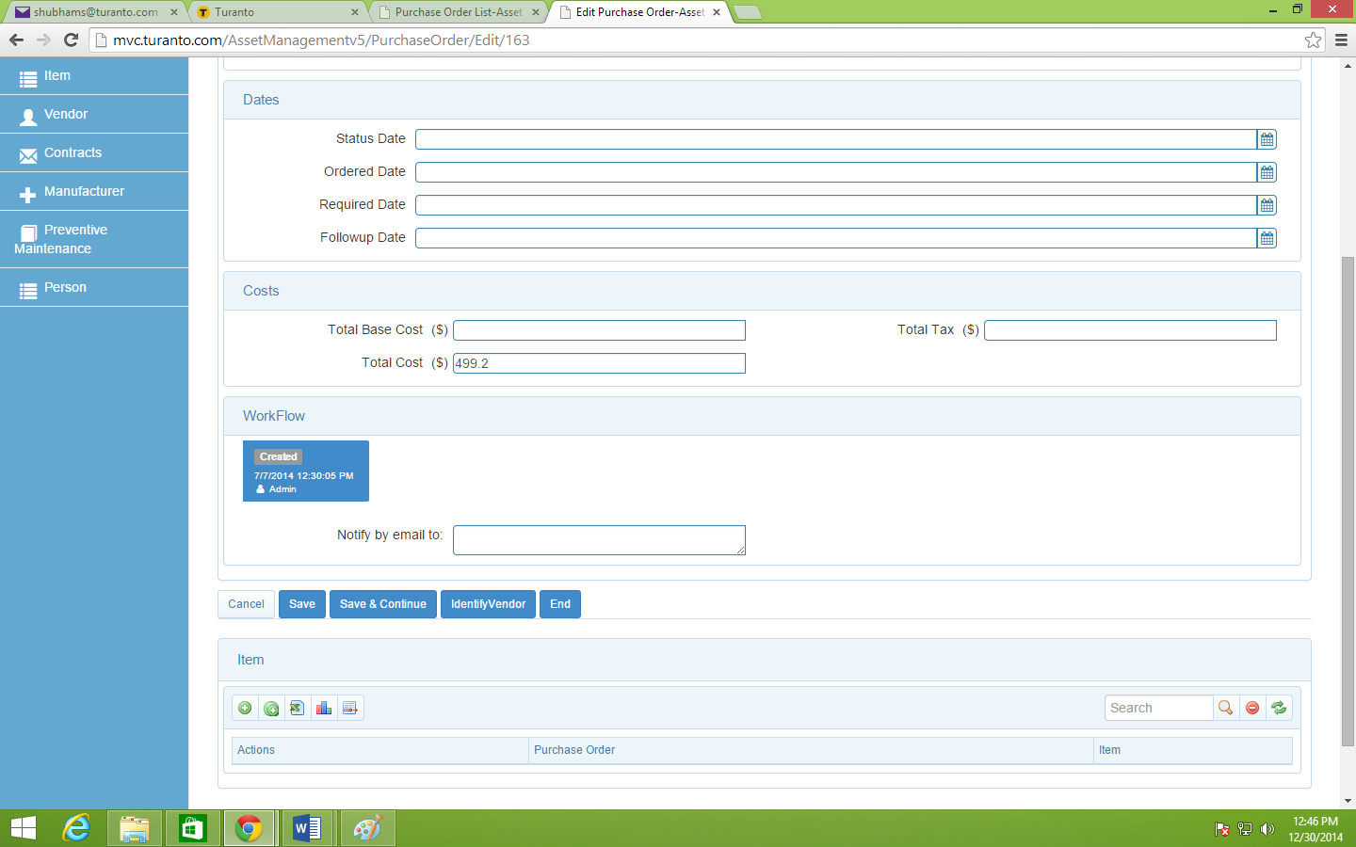

TODO: Replace this Image

Figure : (Example) Edit Page View

### Edit

This option allows editing the fields of record. The option ‘save’ redirect you to detailed page. ‘Save and continue’ save your data and keeps you on same page to edit further. ‘Cancel’ discards your unsaved changes and redirects you to detailed page. Rest options are fields of workflow.

### Workflow

The rights to edit a workflow is restricted only to respective role. The admin (or role with permission) can only assign the next state of workflow (Figure 36). If application is re-launched in middle of workflow, the workflow states will start over in generated application.

### Accordion

Accordion Association displays the associated entity at bottom of detailed page on all tabs (Detailed page and tabs of other associated entities). The accordion can be minimized/expanded by clicking on association name (for example: ‘Item’ in Figure 36). By default accordion association is in expanded view.

### Copy to Entity_name

**If copy entity feature is used in application model**, copy to <entity_name> is visible on respective detailed page. The feature is not default and available only to entities and properties assigned in copy entity. The records of source entity can be copied to target entity either by detailed page or from grid.

Copying from Detailed Page

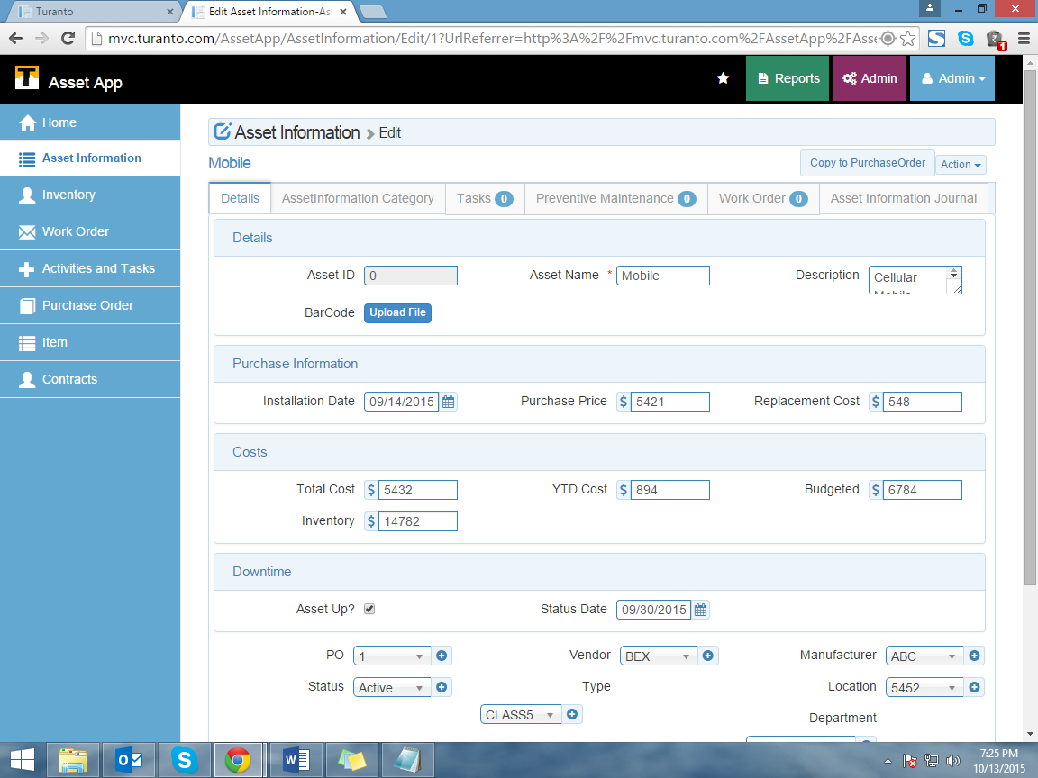

TODO: Replace this Image

Figure : Copy to ‘Purchase Order’

Copying from Grid Page

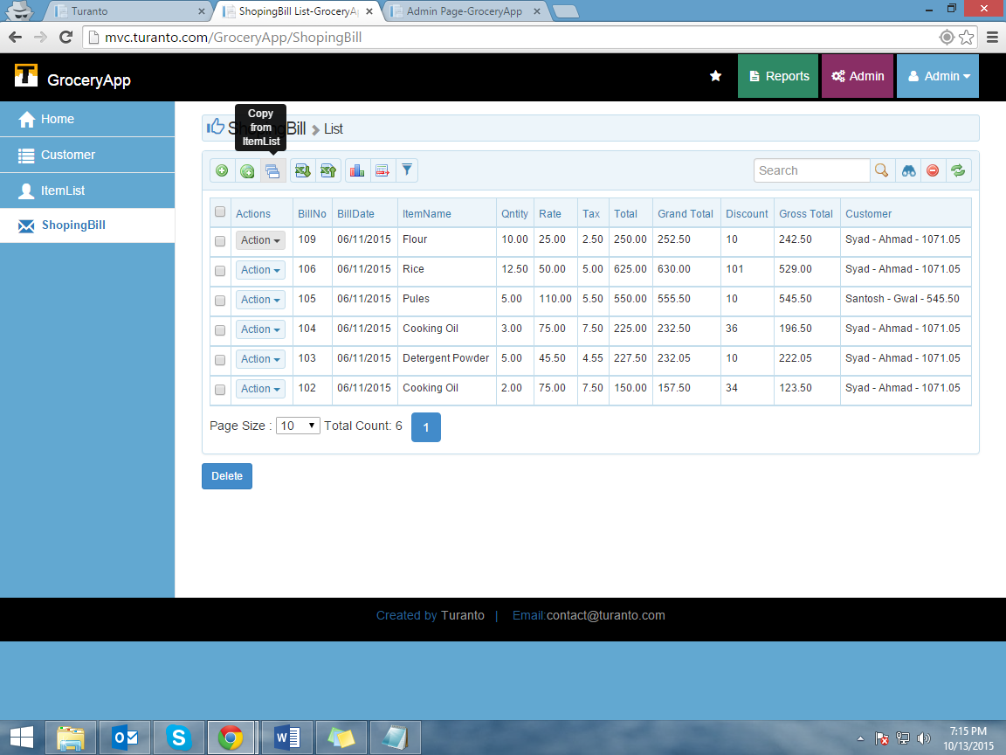

TODO: Replace this Image

Figure : Copying Records from Grid Page

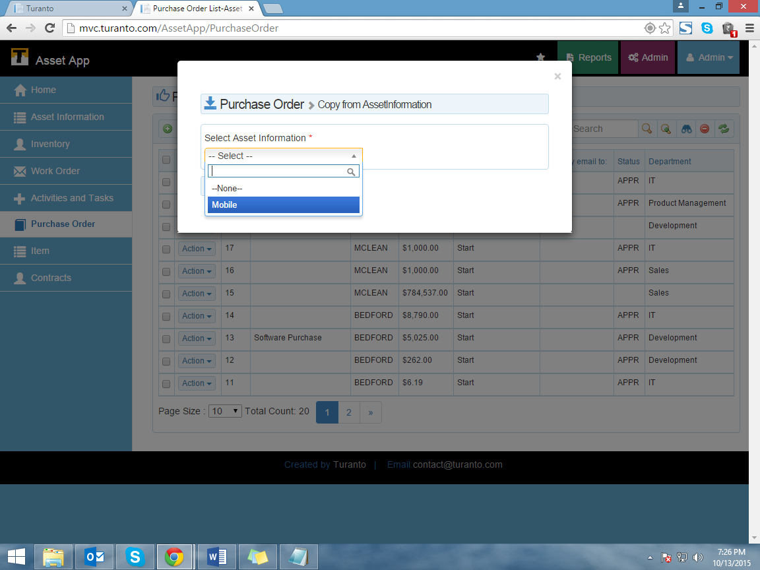

TODO: Replace this Image

Figure : Select Records to be copied

Image Gallery: If selected for a property in application, the images in this property are displayed as slide show.

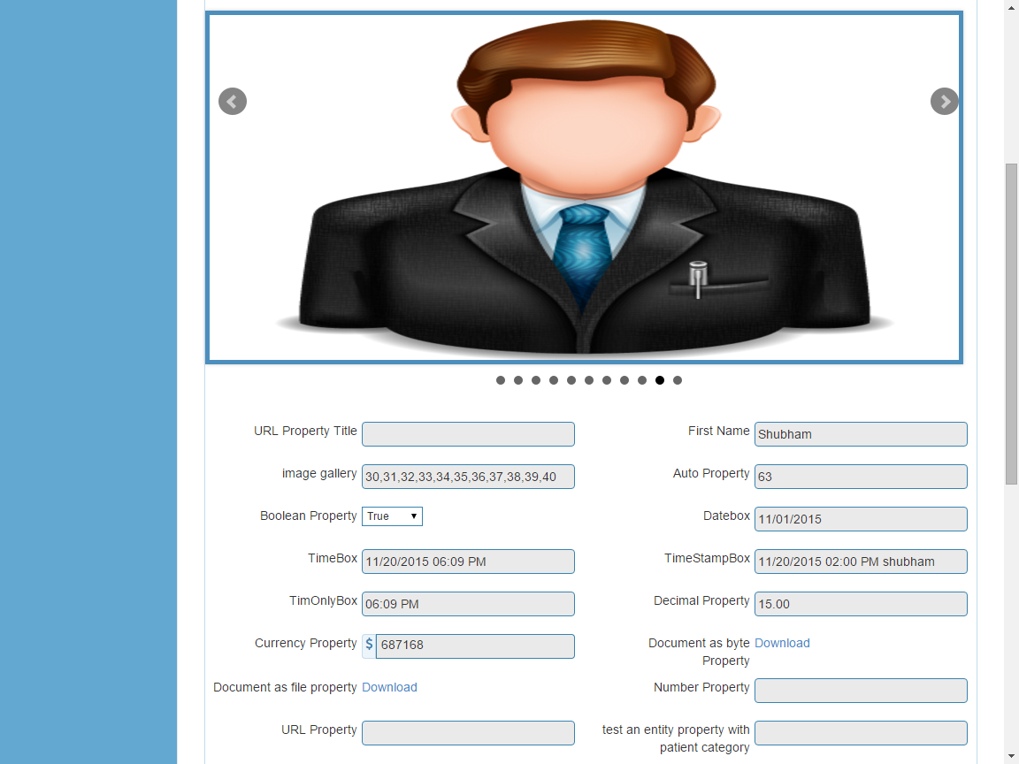

TODO: Replace this Image

Figure : Image Gallery

# Chat

You can chat with your fellow members directly or in groups. The groups are the roles you are assigned to. The other members of role are the group members.

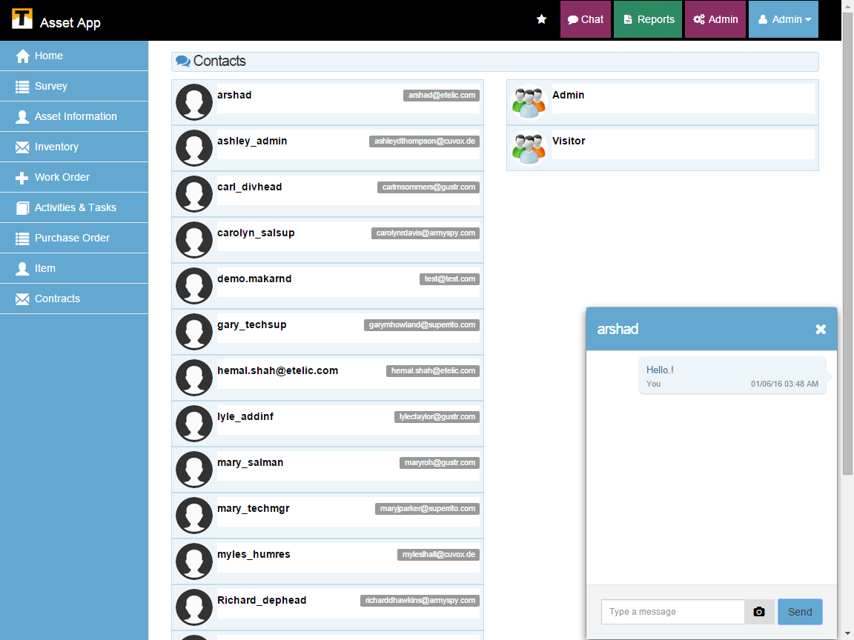

TODO: Replace this Image

Figure : Chat page

The groups are automatically created based on roles. One cannot create or delete the group on his own.

# Appendix 1

## Live Data Monitoring

The entities with enabled option of ‘Real-Time Data Monitoring’ are tracked on real time basis. The application roles with access to view real-time data monitoring can track the actions in an entity. The real time data monitoring page provides information about the username, entity name, date and time and the action performed in the entity. The real-time data monitoring is a self-updated page and records entries of only current time.

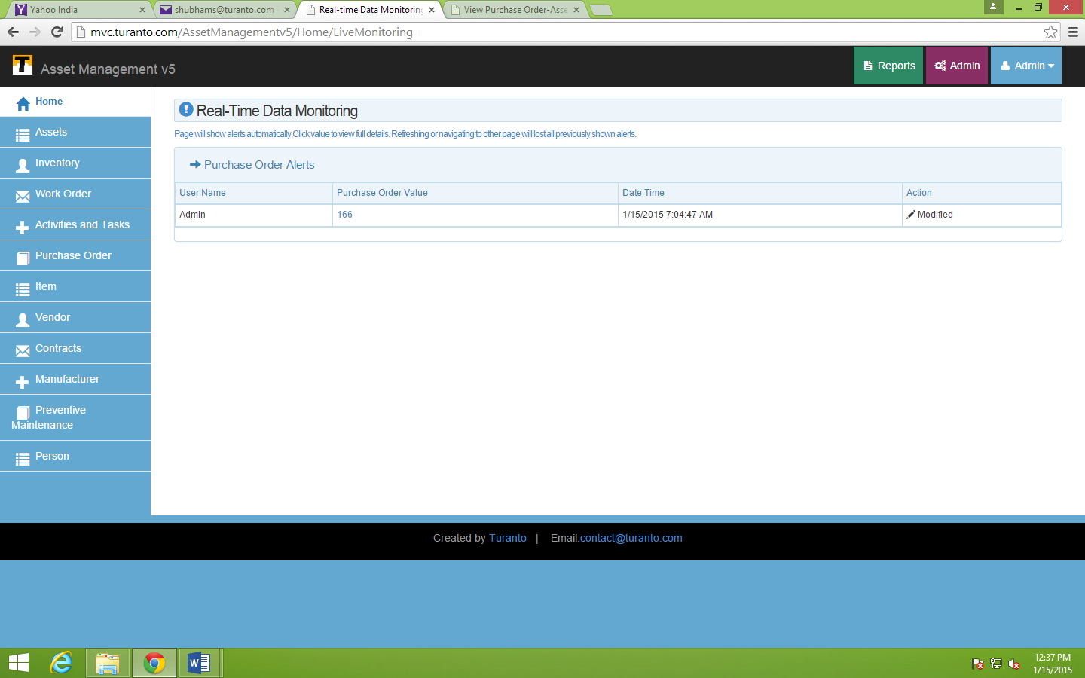

TODO: Replace this Image

Figure A-1: Real-Time Data Monitoring

## Journal

The journal is a section present in ‘more’ options of home page. This page records every activity of application. Figure A-2 shows all the activities tracked in Asset Management v5 application in terms of ‘Entity Name’, Type, Date and Time of Entry, Record Info, Username, Property name (if any), Old Value, New Value and View option to go to that page. The journal entry is assessable only if sufficient permission is given to selected role.

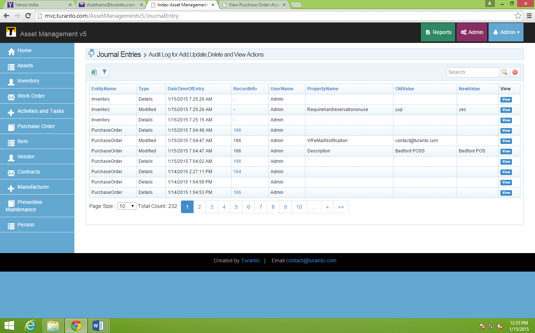

TODO: Replace this Image

Figure A-2: Journal Entries

## Application Feedback

Right click anywhere in the application to send the feedback. The feedback form automatically takes the necessary values and you can simply write the summary and description of your feedback. The submitted feedback is stored in a separate entity and users with sufficient privilege can only see that.

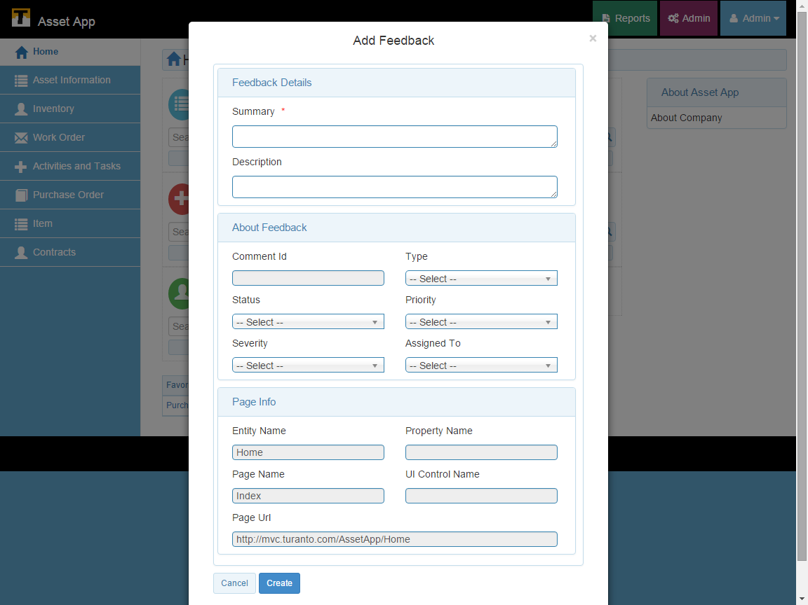

TODO: Replace this Image

Figure : Application Feedback Form